The Story of The Engine That Thought It Could
By Rev. Charles S. Wing
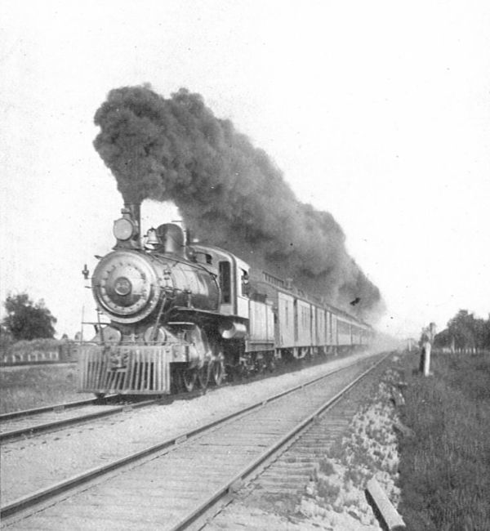

In a certain railroad yard there stood an extremely heavy train that had to be drawn up an unusually heavy grade before it could reach its destination. The superintendent of the yard was not sure what it was best for him to do, so he went up to a large, strong engine and asked: "Can you pull that train over the hill?"

"It is a very heavy train," responded the engine.
He then went to another great engine and asked: "Can you pull that train over the hill?"

"It is a very heavy grade," it replied.
The superintendent was much puzzled, but he turned to still another engine that was spick and span new, and he asked it: "Can you pull that train over the hill?"
"I think I can," responded the engine.

So the order was circulated, and the engine was started back so that it might be coupled with the train, and as it went along the rails it kept repeating to itself: "I think I can. I think I can. I think I can."

The coupling was made and the engine began its journey, and all along the level, as it rolled toward the ascent, it kept repeating to itself: "I ---think ---I can. I ---think ---I--- can. I ---think--- I ---can."

Then it reached the grade, but its voice could still be heard: "I think I can. I----- think-----I-----can. I -----think----- I----- can." Higher and higher it climbed, and its voice grew fainter and its words came slower: "I -------think --------I-------can."

It was almost to the top.
“I ---------think"
It was at the top.
"I ---------can."

It passed over the top of the hill and began crawling down the opposite slope.

'I ------think------- I------ can------I----- thought------I-------could I----- thought----- I----- could. I thought I could. I thought I could. I thought I could."
And singing its triumph, it rushed on down toward the valley.

THE END

