**Over In The Meadow**

**By Olive A. Wadsworth**

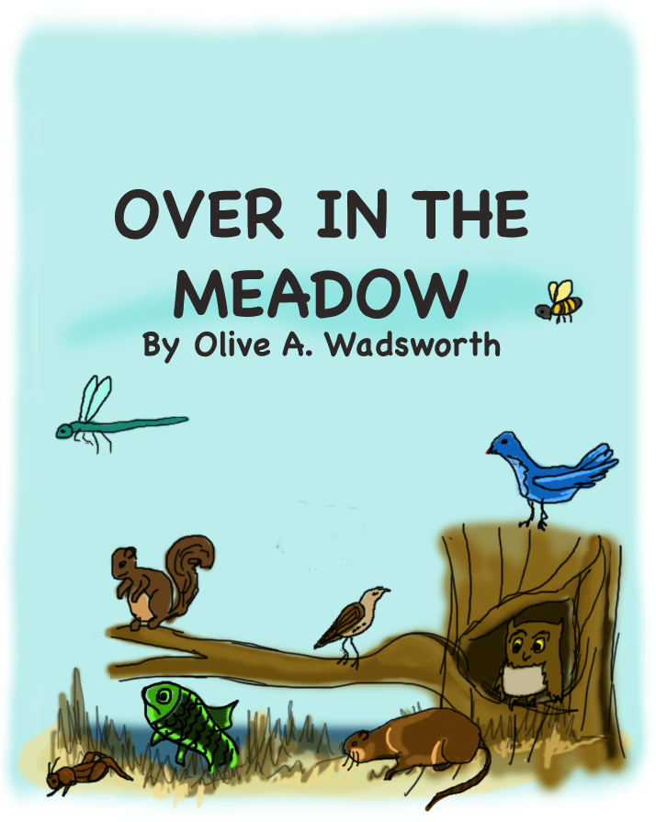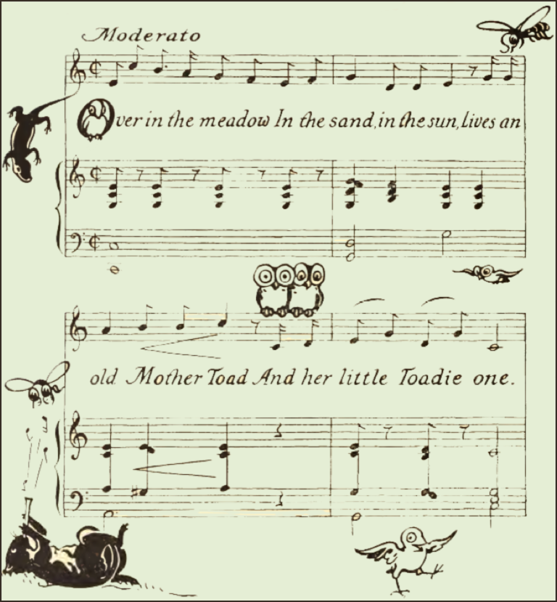

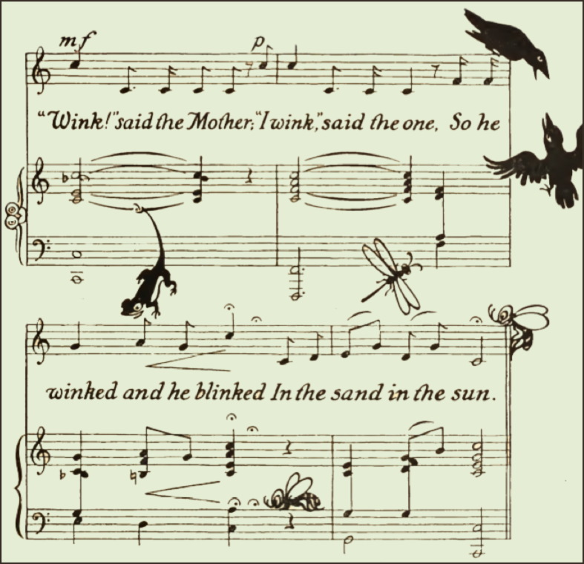

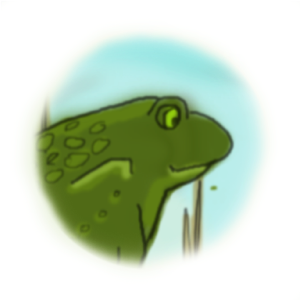

**MOTHER TOAD**

Little Toads most always are

Happy Toads, and kind;

When their mother asks them things,

Toadies always mind.

When they’re told to go to bed,

Or to wash their hands,

Every well-bred little Toad,

Minds and understands.

So do you?

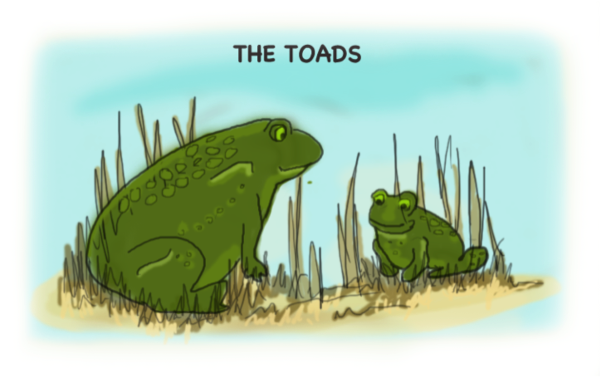

Over in the meadow,

In a hole in a tree,

Lived a mother-blue-bird

And her little birdies three.

“Sing!” said the mother;

“We sing,” said the three:

So they sang, and were glad,

In the hole in the tree.

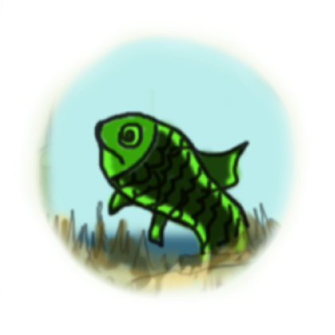

**MOTHER FISH**

Baby Fish are very small,

But their mother knows

Just the place to learn to swim,

Where the water goes.

If she tells them not to go

On the land to play,

They don’t grumble or complain;

Baby Fish obey.

So do you?

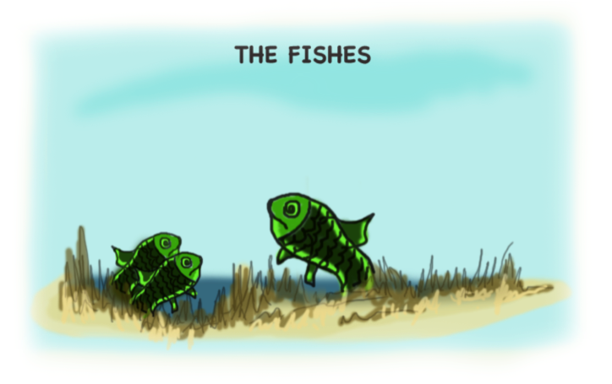

Over in the meadow,

Where the stream runs blue,

Lived an old mother-sish

And her little fishes two.

“Swim!” said the mother;

“We swim,” said the two:

So they swam and they leaped

Where the stream runs blue.

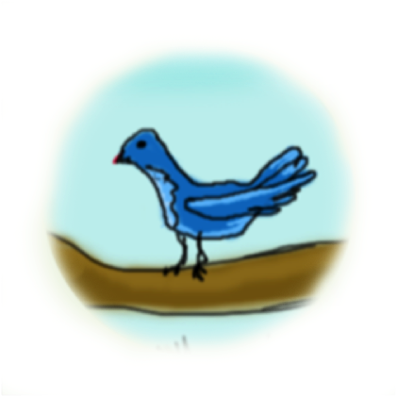

**MOTHER BLUE-BIRD**

Baby Blue-Birds are genteel,

They don’t scratch or bite.

And when Birdies talk to them

They are real polite.

If Jim Crow is rough and gruff,

That’s no reason why

Blue-Birds can’t be courteous,

They at least can try.

So can you.

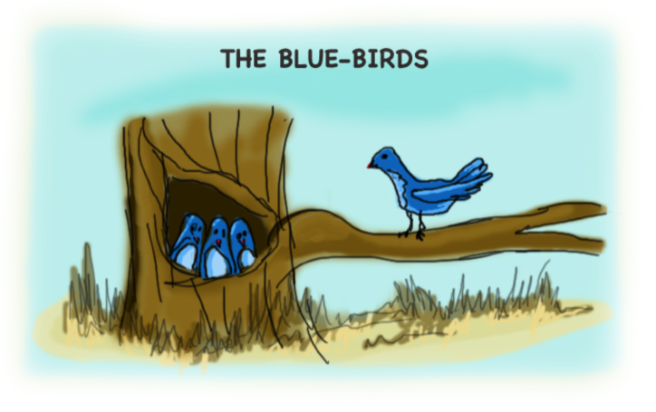

Over in the meadow,

In a hole in a tree,

Lived a mother-blue-bird

And her little birdies three.

“Sing!” said the mother;

“We sing,” said the three:

So they sang, and were glad,

In the hole in the tree.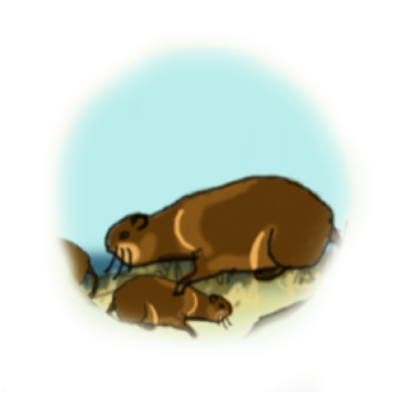

**MOTHER MUSKRAT**

Little Muskrats dig in mud

With their mouths and feet,

But they always bathe a lot,

So are clean and neat.

Never were good, little Rats

Known to tell you lies;

They just tell the truth and look

Straight in mother’s eyes.

So do you?

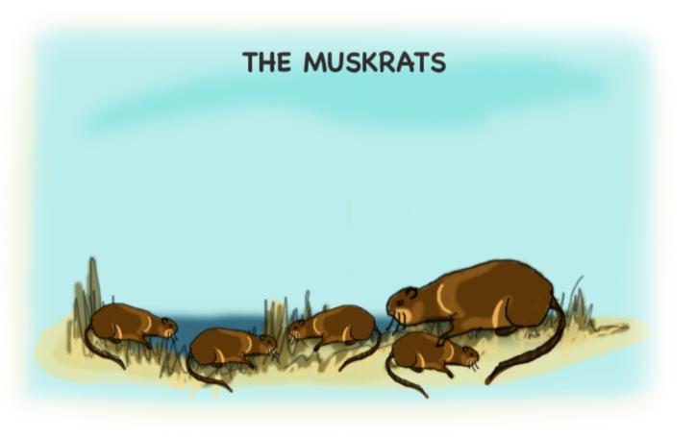

Over in the meadow,

In the reeds on the shore,

Lived a mother-muskrat

And her little ratties four.

“Dive!” said the mother;

“We dive,” said the four:

So they dived and they burrowed

In the reeds on the shore.

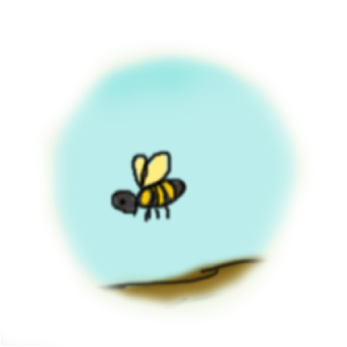

**MOTHER HONEY-BEE**

Little Honey-bees are smart;

They are funny too,

For they work like everything,

Seldom getting through.

Work for Honey-bees is play;

Play for them is work.

Bizzy, buzzy, happy Bees,

Never sulk or shirk

Just like you.

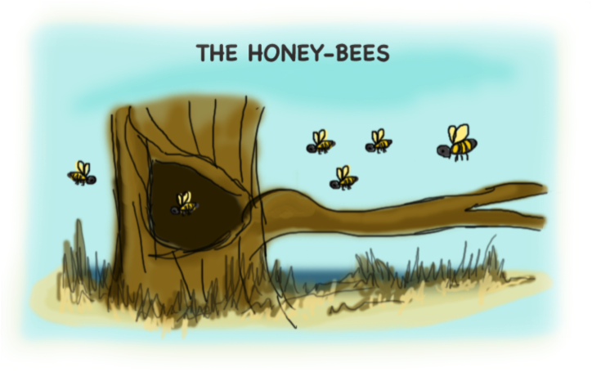

Over in the meadow,

In a snug beehive,

Lived a mother-honeybee

And her little honeys five.

“Buzz!” said the mother;

“We buzz,” said the five:

So they buzzed and they hummed

In the snug beehive.

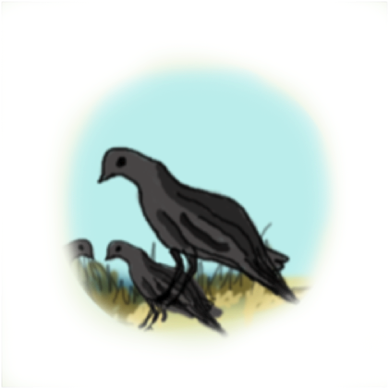

**MOTHER CROW**

Little Baby Blacky Crows,

Caw when mother caws,

Never hiding mouth or eyes

With their little claws.

They just like to go at once

Up into their nest,

For they know that mother knows

Just the thing that’s best.

So do you.

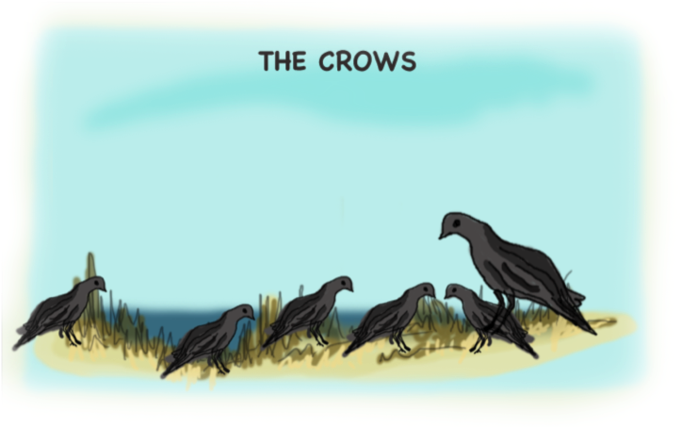

**THE CROWS**

Over in the meadow,

In a nest built of sticks,

Lived a black mother-crow

And her little crows six.

“Caw!” said the mother;

“We caw, said the six:

So they cawed and they called

In their nest built of sticks.

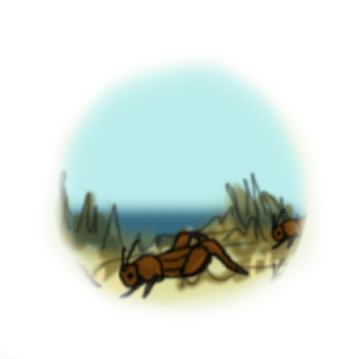

**MOTHER CRICKET**

Little Crickets chip and chirp,

In the meadow grass;

Singing, jolly all the time

As the hours pass.

Never do they sulk or pout,

Moping under ground;

Folks are glad when they’re about,

Folks want them around

Just like you.

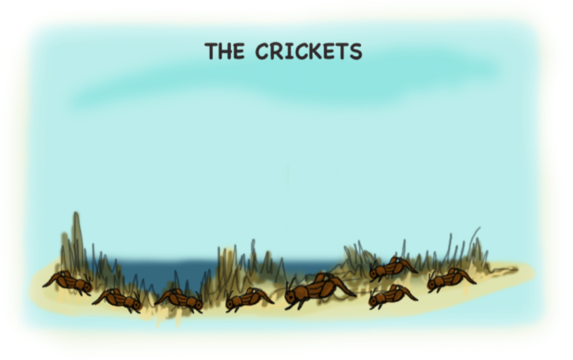

Over in the meadow,

Where the grass is so even,

Lived a gay mother-cricket

And her little crickets seven.

“Chirp!” said the mother;

“We chirp,” said the seven:

So they chirped cheery notes

In the grass soft and even.

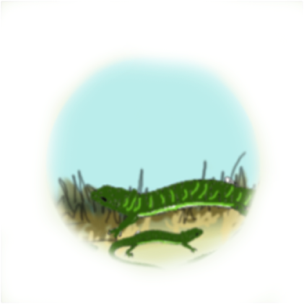

**MOTHER LIZARD**

Little Lizards love to play

In the golden sun,

‘Cause it’s very good for them

And because it’s fun.

But when mother tells them to

Study from their books,

Lizards never whine or cry,

Or give sulky looks

Nor do you.

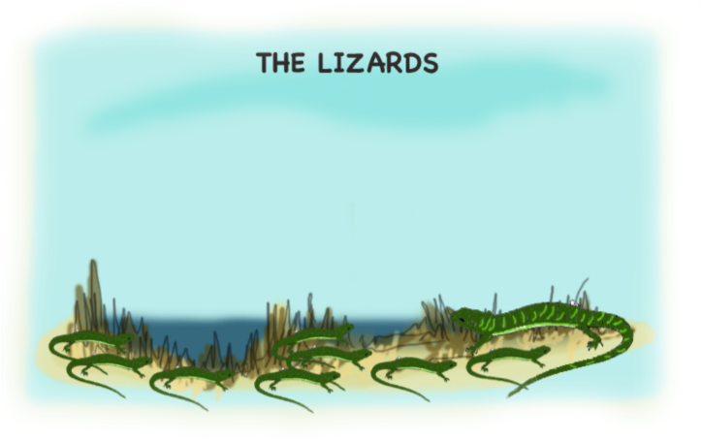

Over in the meadow,

By the old mossy gate,

Lived a brown mother-lizard

And her little lizards eight.

“Bask!” said the mother;

“We bask,” said the eight:

So they basked in the sun

On the old mossy gate.

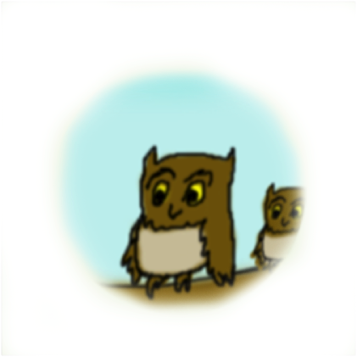

**MOTHER OWL**

Little Owls like the night

Better than the day.

They aren’t frightened in the dark:

“Dark can’t hurt,” they say.

And they eat exactly what’s

Given them for food;

Saying “Thank you, mother,” and

Chewing fine and good.

So do you.

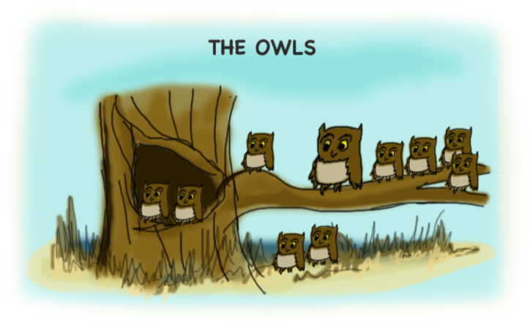

Over in the meadow,

Near the post-road sign,

Lives a gray mother-owl

And her little owlies nine.

“Hoot!” said the mother;

“We hoot,” said the nine:

So they hooted and they tooted

Near the post-road sign.

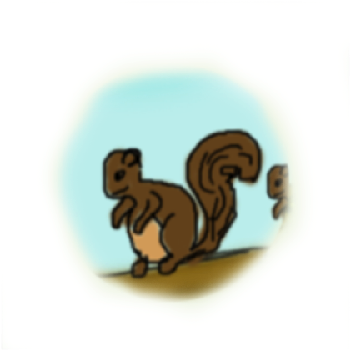

**MOTHER SQUIRREL**

Little Squirrels chatter some;

So do Girls and Boys’

But their jolly chattering

Never once annoys

Mother Squirrel, for you see,

They don’t shout or shriek,

But use gentle words and voice

Always when the speak.

Just like you.

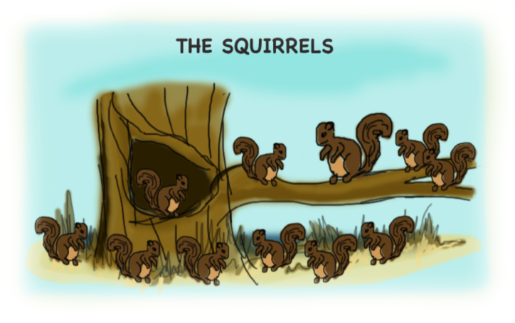

Over in the meadow,

In a cozy little den,

Lives an old mother-squirrel

And her little squirrels ten.

“Munch!” said the mother;

“We munch,” said the ten:

So they munched and they crunched

In the cozy little den.

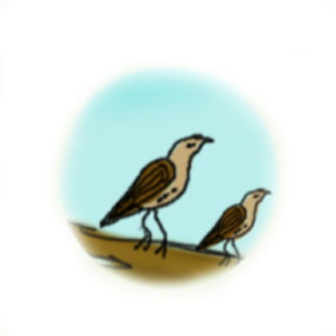

**MOTHER LARK**

Little Larks are dear as dear,

Every song they sing

Bubbles from their throats and hearts

Like a crystal spring.

That’s because their thoughts are pure,

And their hearts are glad.

So they never think or say Naughty things, or bad.

Nor do you.

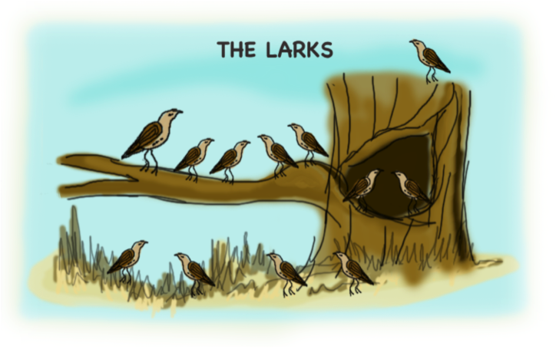

Over in the meadow,

Where the grass touches heaven,

Lives an old mother-lark

And her little larkies eleven.

“Sour!” said the mother;

“We sour,” said the eleven:

So they soared and they soared

Up, up into heaven.

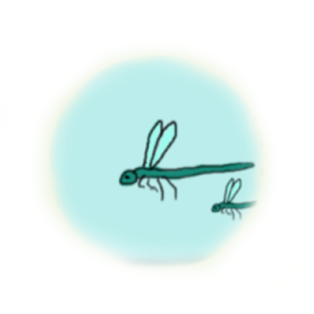

**MOTHER DRAGON-FLY**

Little Dragon-flies are smart;

They are quick and spry,

All around they flit and go,

But they always fly

Home again before the sun

Drops far out of sight.

Then they’re put to bed and say,

“Mother, dear, GOOD NIGHT.”

So do you.

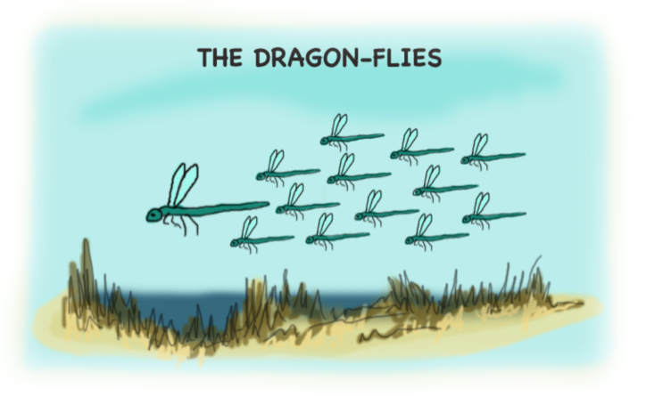

Over in the meadow,

Where the gray rocks shelve,

Lives a mother-dragon-fly

And her little dragons twelve.

“Hum!” said the mother;

“We hum,” said the twelve:

So they hummed in the sun

Where the gray rocks shelve.



**THE END**