McGuffey’s First Reader

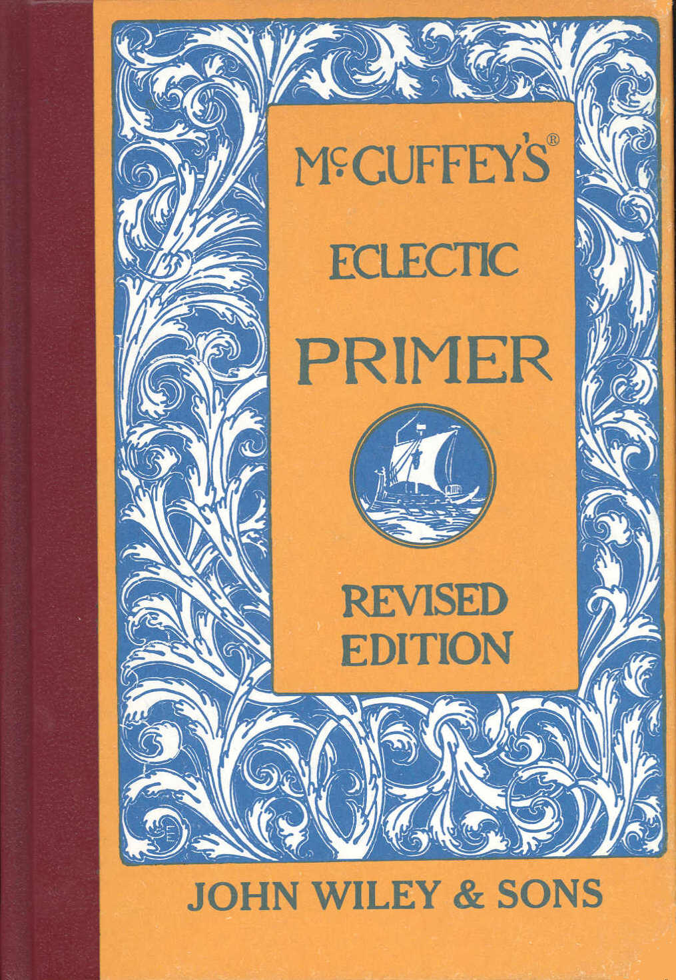

ECLECTIC EDUCATIONAL SERIES.

McGUFFEY'S®

ECLECTIC PRIMER.

REVISED EDITION.

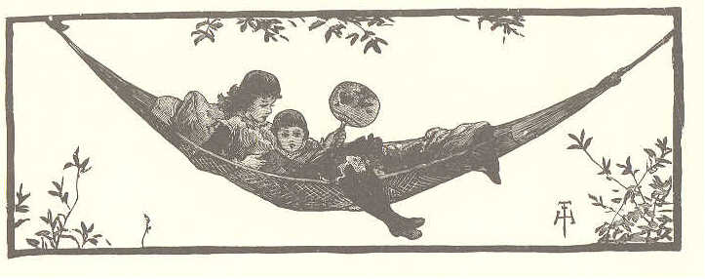

McGuffey Editions and Colophon are Trademarks of
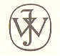
JOHN WILEY & SONS, INC.
NEW YORK - CHICHESTER - WEINHEIM - BRISBANE - SINGAPORE - TORONTO

Copyright, 1881, By Van Antwerp, Brag & Co.

Copyright, 1896, By American Book Company.

Copyright, 1909, By Henry H. Vail.

EP 179
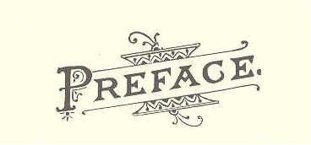

The flattering success of McGuffey's Revised Readers, and the inquiry for more primary reading matter to be used in the first year of school work, have induced the Publishers to prepare a REVISED PRIMER, which may be used to precede the First Reader of any well arranged series.
The method pursued is the same as that in McGuffey's Revised Readers, and the greatest possible care has been taken to insure a gradation suited to the youngest children. Only about six new words are to be mastered in each lesson. These new words and the new elementary sounds are always to be found in the vocabulary of the lesson in which they are first used.
The plan of the book enables the teacher to pursue the Phonic Method, the Word Method, the Alphabet Method, or any combination of these methods.
Illustrations of the best character have been freely supplied, and the skilled teacher will be able to use them to great advantage.
The script exercises throughout the book and the slate exercises at the close, have been specially written and carefully engraved for this Primer; they may be used to teach the reading of script, and as exercises in learning to write.
In the full confidence that the public will appreciate a cheap and attractive Primer of this character, the Publishers have spared no expense to make this book equal, in type, paper, and illustrations, to any that have been issued from their Press.
(iii)
4 ECLECTIC SERIES.

THE ALPHABET.

A | B | C | D
E | F | G | H
I | J | K | L
M | N | O | P
Q | R | S | T
U | V | W | X
 | Y | Z

ECLECTIC SERIES. 5

THE ALPHABET.

a | b | c | d
e | f | g | h
I | j | k | l
m | n | o | p
q | r | s | t
u | v | w | x
 | y | z

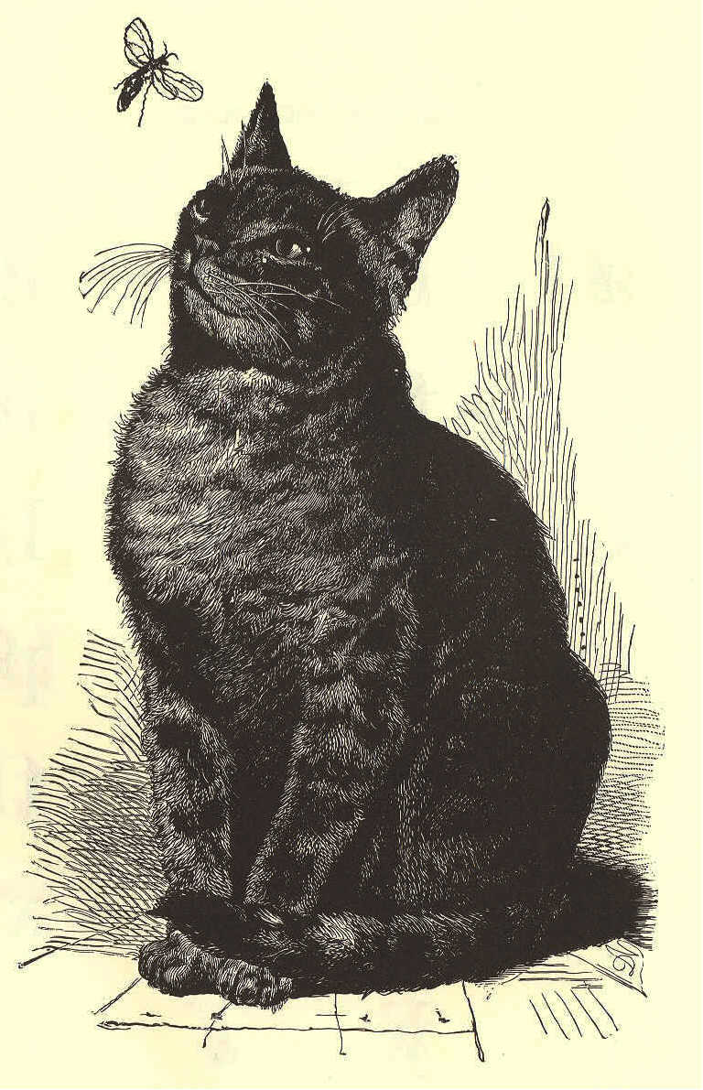
ECLECTIC SERIES. 7
McGuffey's

Eclectic Primer

Lesson 1

a and eat rat

a e d n r t
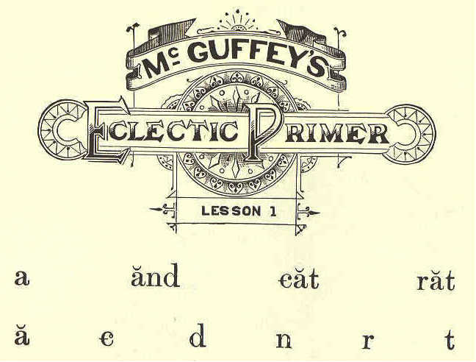

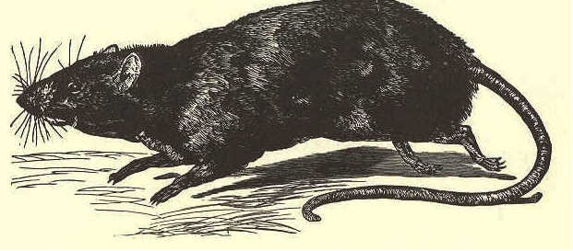
a rat a cat

A cat A rat

A cat and a rat.

A rat and a cat.
8 ECLECTIC SERIES.

LESSON II.
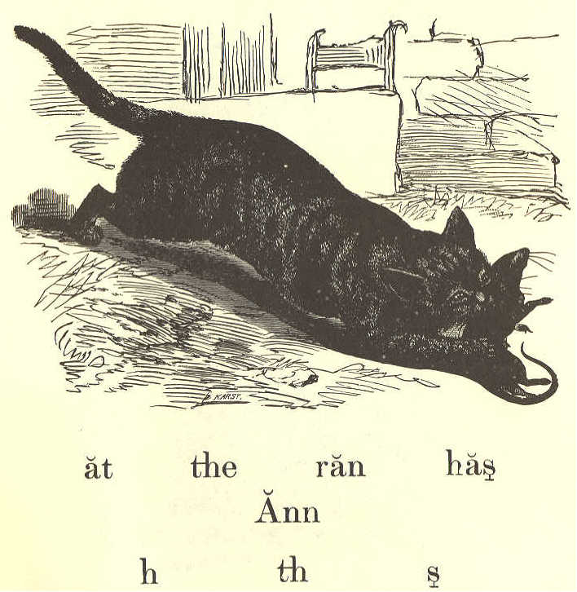
at the ran has
Ann
h th s

The cat the rat
The cat has a rat.
The rat ran at Ann.
Ann has a cat.
The cat ran at the rat.
McGUFFEY'S PRIMER. 9

LESSON III.

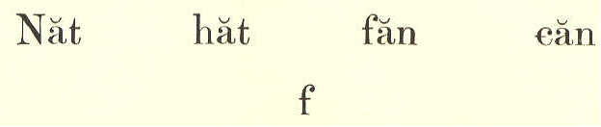
Nat hat fan can
f
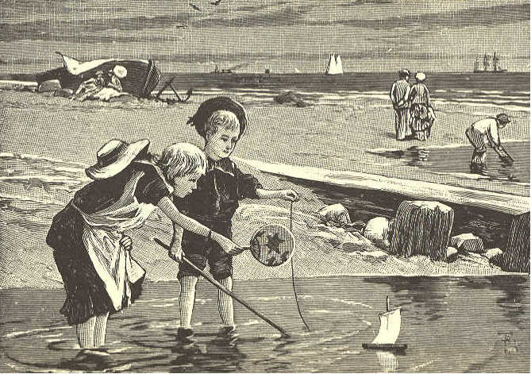

a fan a hat

Ann and Nat.
Ann has a fan.
Nat has a hat.
Ann can fan Nat.
10 ECLECTIC READER

LESSON IV.

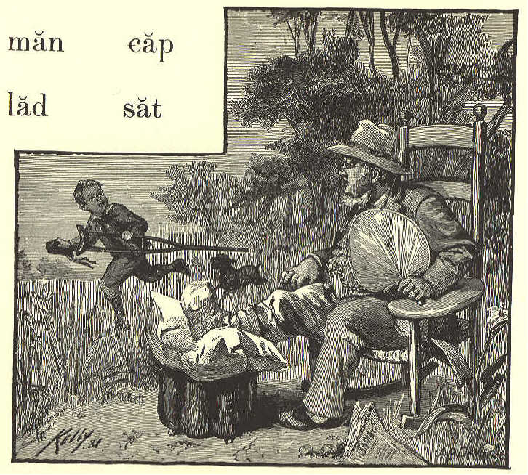
man cap
lad sat
1 m p s
l m p s

a cap the lad

A man and a lad.
The man sat; the lad ran.
The man has a hat.
The lad has a cap.
McGUFFEY'S PRIMER. 11

LESSON V.-REVIEW.

The cat and the rat ran.
Ann sat, and Nat ran.
A rat ran at Nat.
Can Ann fan the lad?
The man and the lad.
The man has a cap.
The lad has a fan.
Has Ann a hat?
Ann has a hat and a fan.

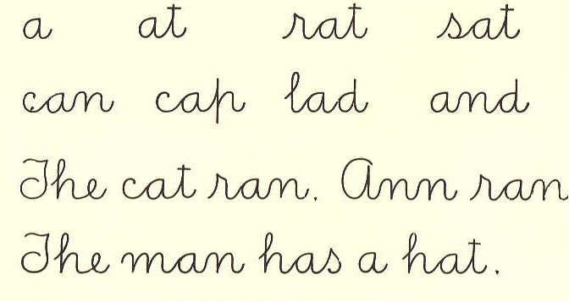
a at rat sat
can cap lad and
The cat ran. Ann ran.
The man has a hat.

12 ECLECTIC READER

LESSON VI.

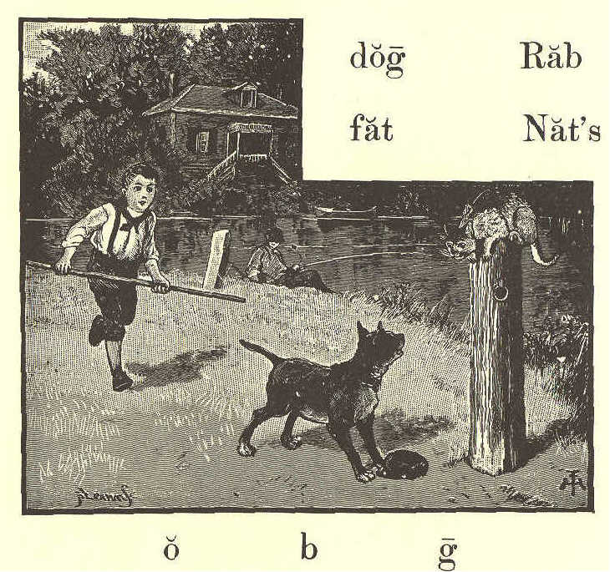
o b g
dog Rab

fat Nat's

Nat's cap a fat dog

Has the lad a dog?
The lad has a fat dog.
The dog has Nat's cap.
Nat and Rab ran.
Rab ran at a cat.
McGUFFEY'S PRIMER. 13

LESSON VII.

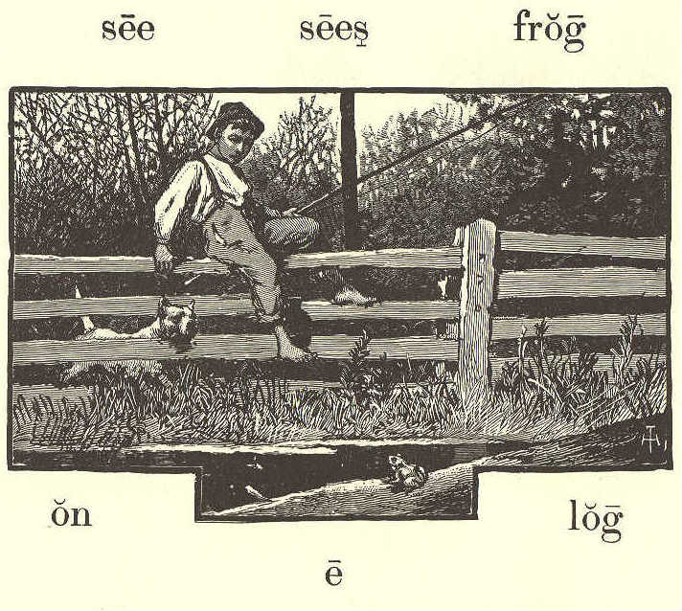
on log

e
see sees frog

a log the frog

See the frog on a log.
Rab sees the frog.
Can the frog see Rab?
The frog can see the dog.
Rab ran at the frog.
14 ECLECTIC SERIES.

LESSON VIII.
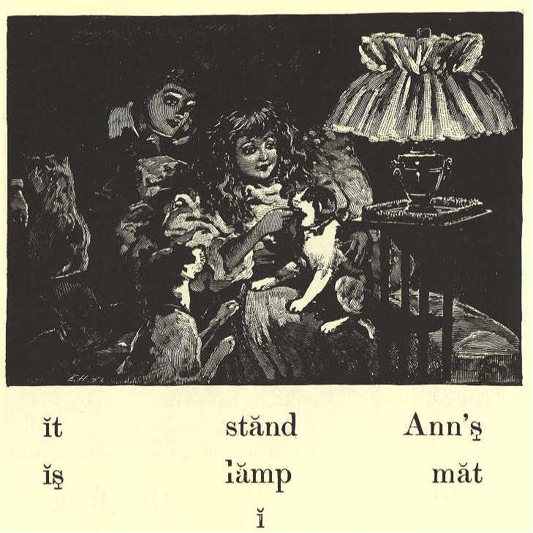
it stand Ann's

is lamp mat
i

a mat the stand

See the lamp! It is on a mat.
The mat is on the stand.
The lamp is Nat's, and the mat is Ann's.
McGUFFEY'S PRIMER, 15

LESSON IX.

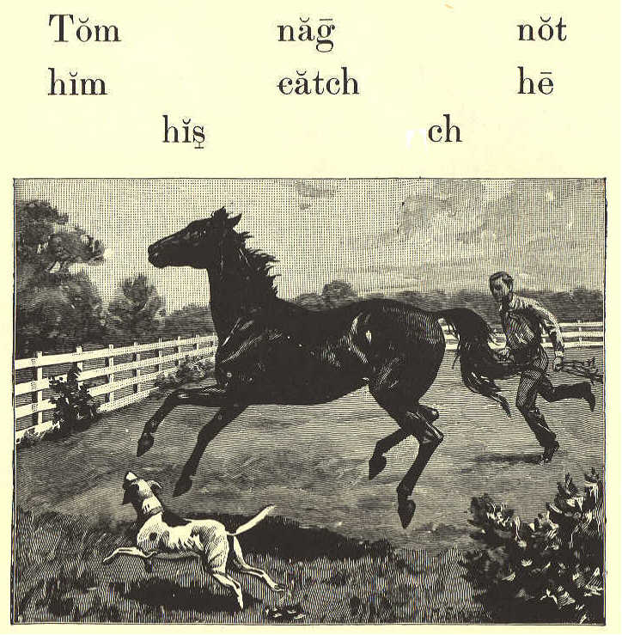
Tom nag not
him catch he
his ch

See the nag! It is Tom's nag.
Can Tom catch his nag?
He can not catch him.
The dog ran at the nag, and the nag ran.
16 ECLECTIC SERIES.

LESSON X.-REVIEW.

Tom's nag is fat; his dog is not fat.
Nat is on Tom's nag.
Nat's dog, Rab, can not catch the rat.
See the frog on the log.
A lad sees the frog.
The lad can not catch it.
A cat is on the mat; the cat sees a rat.
Ann's fan is on the stand.
The man has a lamp.
A dog ran at the man.
Ann sat on a log.

Tom sees Nat's dog.
A fat frog is on the log.
Can not Rab catch it?

McGUFFEY'S PRIMER. 17

LESSON XI

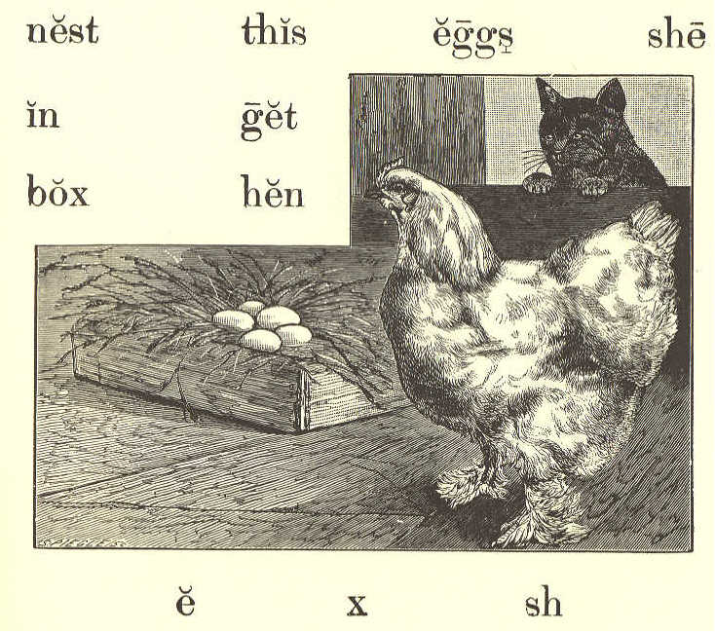
e x sh
nest this eggs she

in get

box hen

the box a nest

This is a fat hen.
The hen has a nest in the box.
She has eggs in the nest.
A cat sees the nest, and can get the eggs.
18 ECLECTIC SERIES.

LESSON XII.

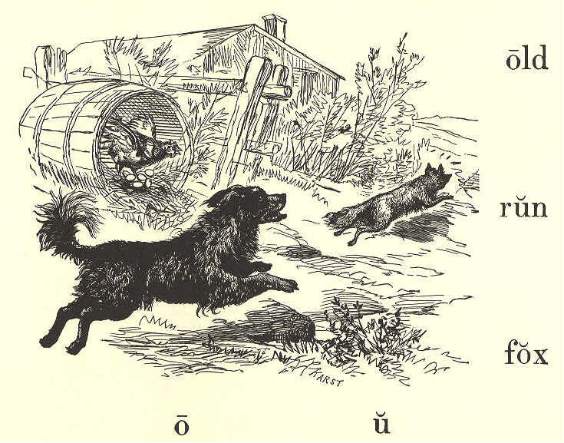
old
run
fox
o u

Can this old fox catch the hen?

The fox can catch the hen, and get the eggs in the nest.

Run, Rab, and catch the fox.
This nest has eggs in it.
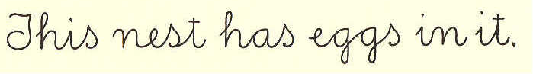

McGUFFEY'S PRIMER 19

LESSON XIII.

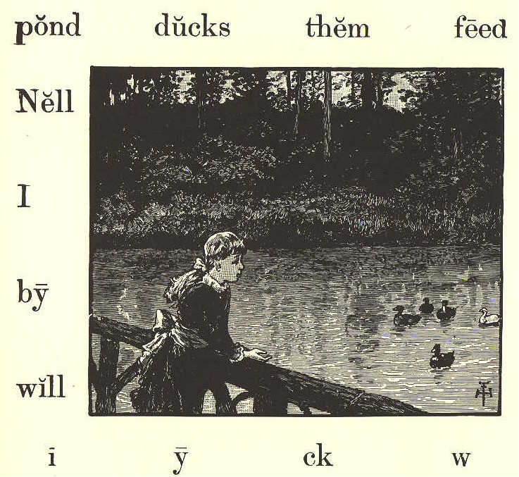
pond ducks them feed
Nell
I
by
will
i y ch w

Nell is by the pond.
I see ducks on the pond.
Nell sees the ducks, and will feed them.
She can not get the ducks.
20 ECLECTIC SERIES.

LESSON XIV.

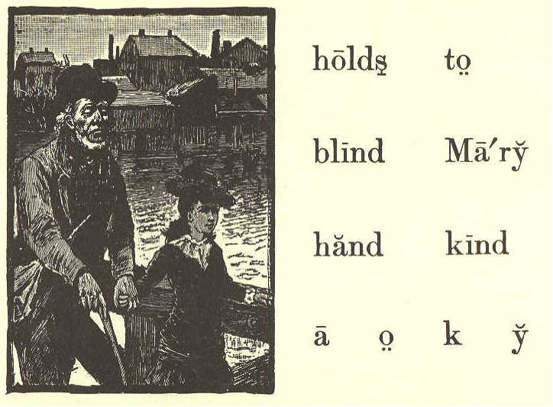
holds to
blind Mary
hand kind
a o k y

This old man can not see.
He is blind.
Mary holds him by the hand.
She is kind to the old blind man.

LESSON XV.-REVIEW.

I see ducks on the pond; Tom will feed them.
McGUFFEY'S PRIMER 21

Tom is blind; he holds a box in his hand.
Nell is kind to him.
This old hen has a nest.
Mary will run and get the eggs.

LESSON XVI.

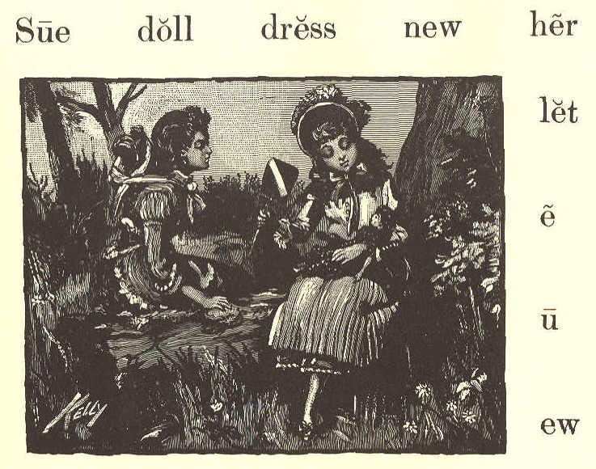
Sue doll dress new her
let
e
u
ew

Sue has a doll.
It has a new dress.
22 ECLECTIC SERIES.

She will let Ann hold the doll in her hands, and Ann will fan it.

Sue is kind to Ann.

LESSON XVII.

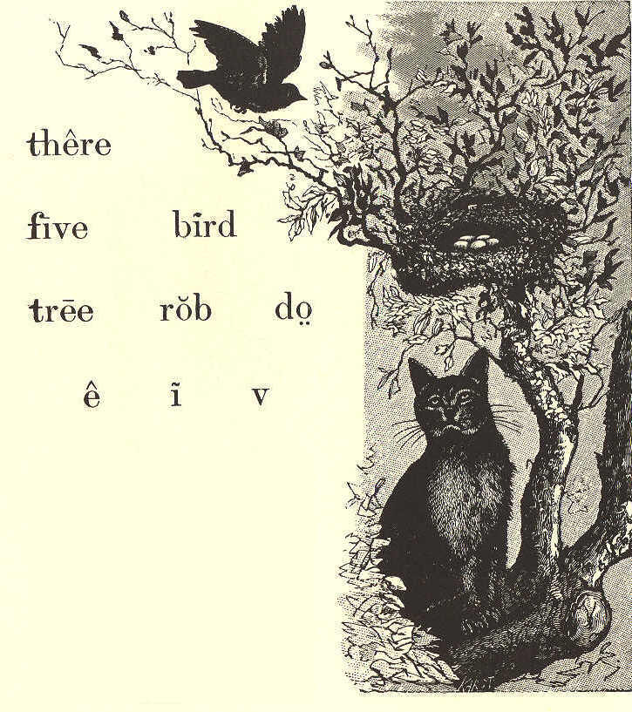
there
five bird
tree rob do
e i v

A bird is in the tree. It has a nest there.
The nest has five eggs in it.
McGUFFEY'S PRIMER. 23

Do not rob the nest.
Will the bird let the cat get her five eggs?

LESSON XVIII.

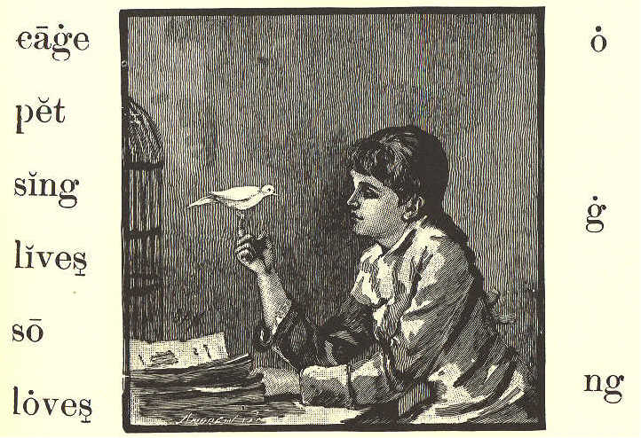
cage o
pet
sing g
lives
so
loves ng

This is a pet bird.
It lives in a new cage.
It will stand on Sue's hand, and sing.
Sue loves her pet bird.
So do I love it.
24 ECLECTIC SERIES.

LESSON XIX.

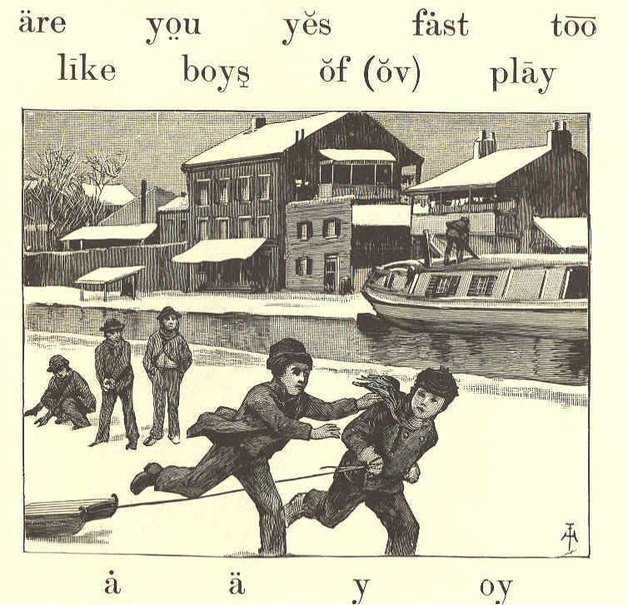
are you yes fast too
like boys of (ov) play

a a y oy

Do you see the boys at play?
Yes, I see them; there are five of them.
Tom is too fat to run fast.
Nat can catch him.
I like to see boys play.
McGUFFEY'S PRIMER. 25

LESSON XX.-REVIEW.

Sue has a doll and a pet bird.
Her doll has a new dress and a cap.
Sue loves Mary, and will let her hold the doll.
The pet bird lives in a cage. Sue and Mary will stand by the cage, and the bird will sing.
There are birds in the tree by the pond. Can you see them?
Yes; there are five of them in a nest.
Tom will not rob a bird's nest. He is too kind to do so.

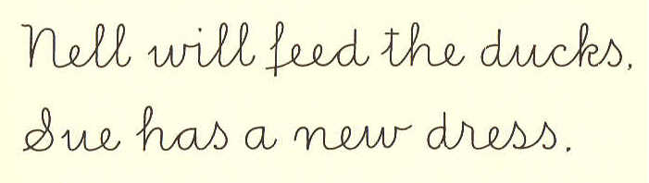
Nell will feed the ducks.
Sue has a new dress.

26 ECLECTIC SERIES.

LESSON XXI.

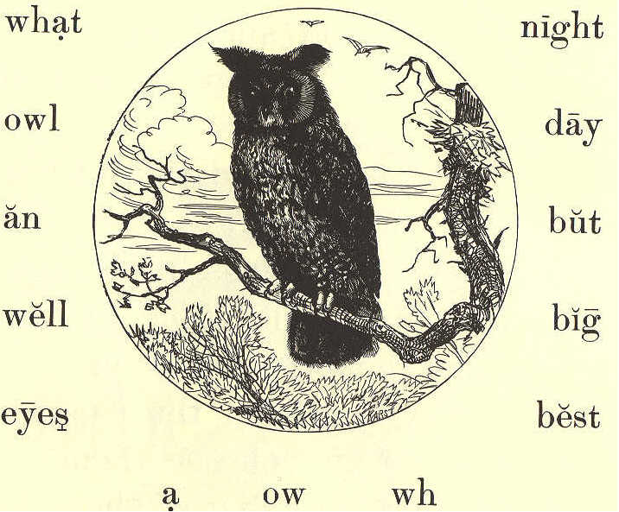
what night
owl day
an but
well big
eyes best
a ow wh

What bird is this? It is an owl.
What big eyes it has!
Yes, but it can not see well by day.
The owl can see best at night.
Nat Pond has a pet owl.
McGUFFEY'S PRIMER. 27

LESSON XXII.

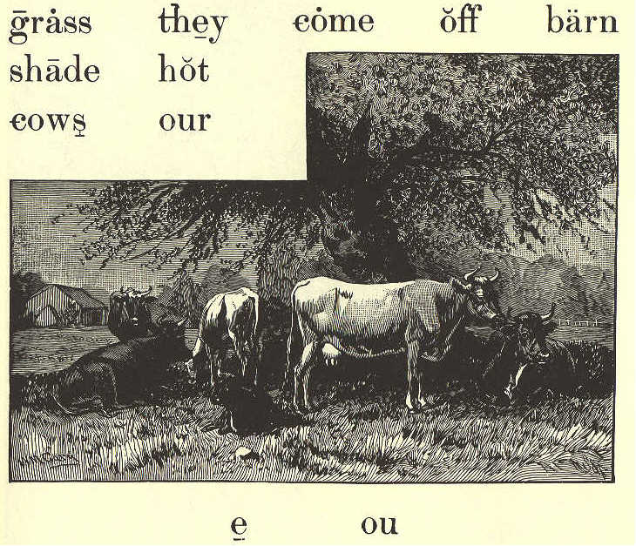
grass they come off barn
shade hot
cows out

e ou

The day is hot.
The cows are in the shade of the big tree.
They feed on the new grass.
Our cows do not run off.
At night they come to the barn.
28 ECLECTIC SERIES.

LESSON XXIII.

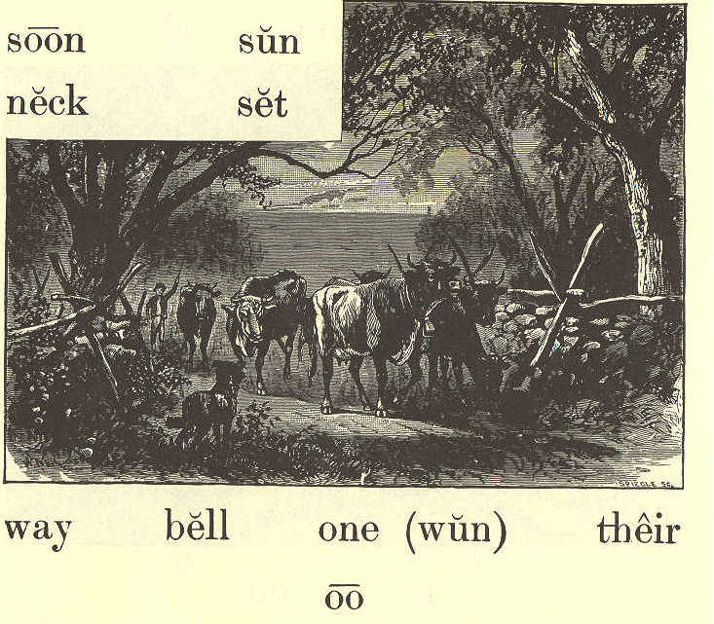
soon sun

neck set

way bell one (wun) their
oo

The sun will soon set.
The cows are on their way to the barn.
One old cow has a bell on her neck. She sees our dog, but she will not run.
Our dog is kind to the cows.
McGUFFEY'S PRIMER. 29

LESSON XXIV.

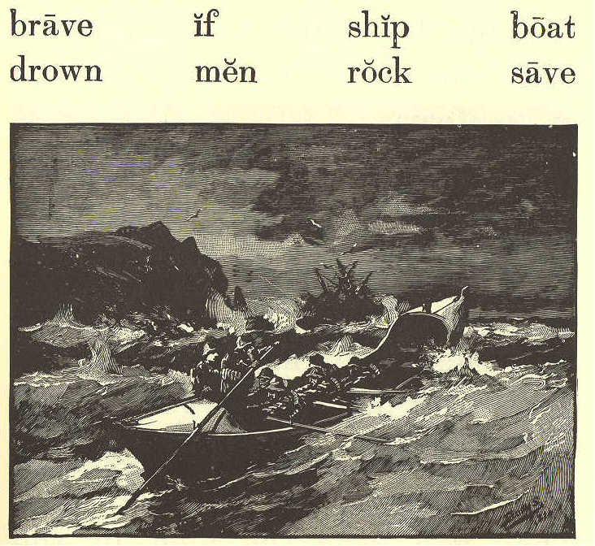
brave if ship boat
drown men rock save

The ship has run on a rock.
Five men are on the ship.
If the boat can not get to them, they will drown.
The boat has brave men in it. They will save the five men.
30 ECLECTIC SERIES.

LESSON XXV.--REVIEW.

Come, boys, and feed the cows. The sun has set, and they are at the barn.
Sue has a bell on the neck of her pet cat.
One hot day Ann and Nell sat on the grass in the shade of a big tree. They like to rock their dolls, and sing to them.
The brave men in our boat are on their way to the ship. They will save the men in the ship, if they can. They will not let them drown.
What bird has big eyes? The owl. Can an owl see at night? Yes, an owl can see best at night.
McGUFFEY'S PRIMER. 31

LESSON XXVI.

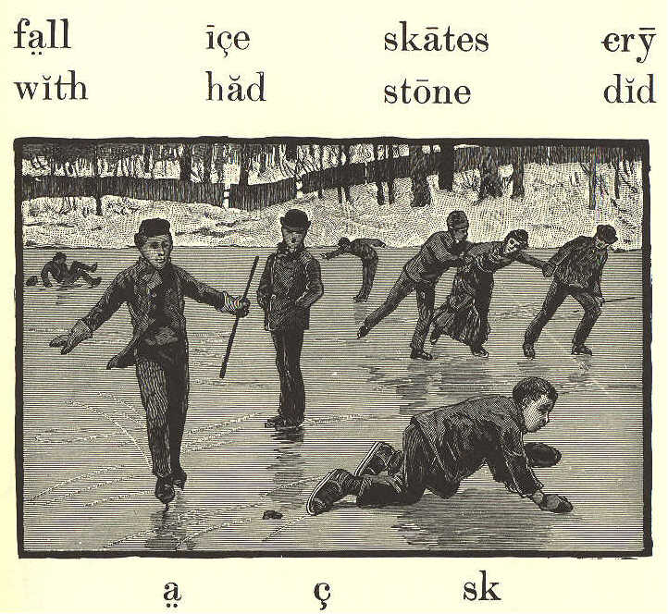
fall ice skates cry
with had stone did
a c sk

The boys are on the ice with their skates.
There is a stone on the ice.
One boy did not see it, and has had a fall.
But he is a brave boy, and will not cry.
32 ECLECTIC SERIES.

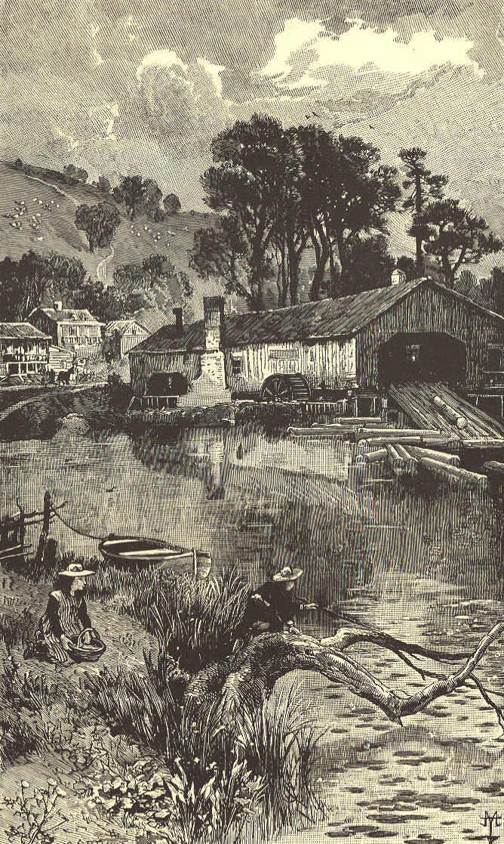
McGUFFEY'S PRIMER. 33

LESSON XXVII.
look go John
here all wheel
mill have round
oo j
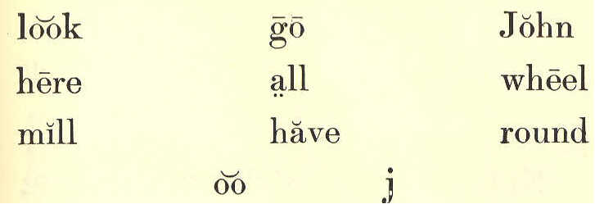

Look! there are John and Sue by the mill pond.
They like to see the big wheel go round.
They have come to play on the logs and in the boat.
John and Sue will play here all day.

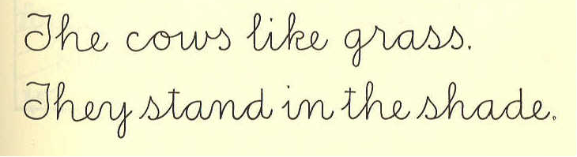
The cows like grass.
They stand in the shade.

34 ECLECTIC SERIES.

LESSON XXVIII.

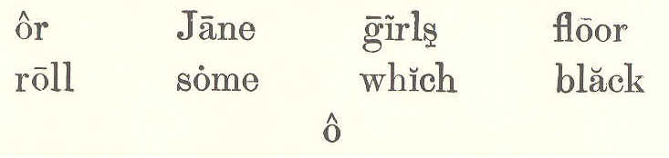
or Jane girls floor
roll some which black
o

Here are some girls with skates; but they are not on the ice.
Their skates roll on the floor. Which way do you like to skate,--on the ice, or on the floor?
The girl with the new black dress is Jane Bell.
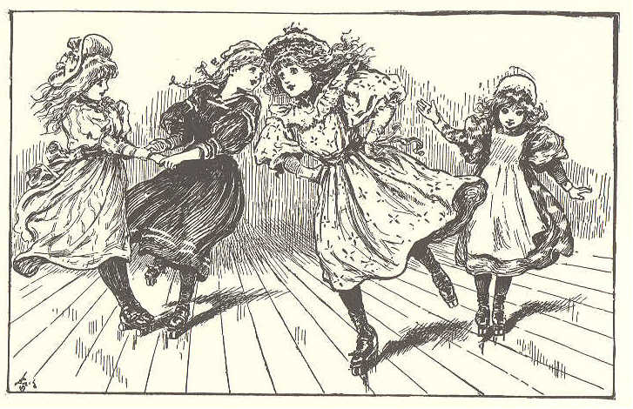
McGUFFEY'S PRIMER. 35

LESSON XXIX.

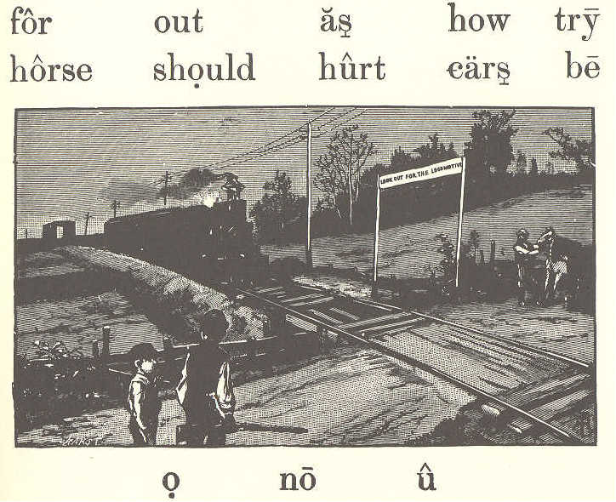
for out as how try
horse should hurt ears be

o no u

Look out for the cars!
How fast they come!
No horse can go as fast as the cars.
I will not try to catch them, for I should fall and be hurt.
See the horse look at the cars.
Will he not run?
36 ECLECTIC SERIES.

LESSON XXX.-REVIEW.

There is ice on the pond, and the mill wheel can not go round.
The boys are all out on the ice with their skates.
I will let you and Tom try to skate; but do not fall, for you will be hurt.
Look! here come the cars.
John and Nat try to skate as fast as the cars go, but they call not. John has had a fall.
The girls are not on the pond; but some of them have skates which roll on the floor.

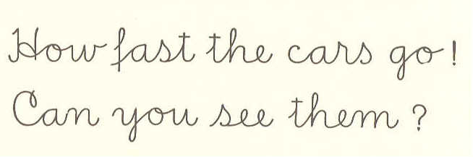
How fast the cars go!
Can you see them?

McGUFFEY'S PRIMER. 37

LESSON XXXI.

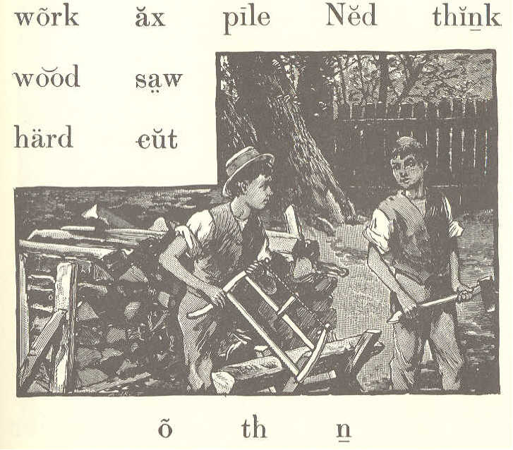
work ax pile Ned think
wood saw
hard cut

o th n

Ned and John are hard at work. John has a saw, and Ned has an ax.
They will try to cut all of the wood which you see in the pile.
Do you think they can do this in one day?
38 ECLECTIC SERIES.

LESSON XXXII.

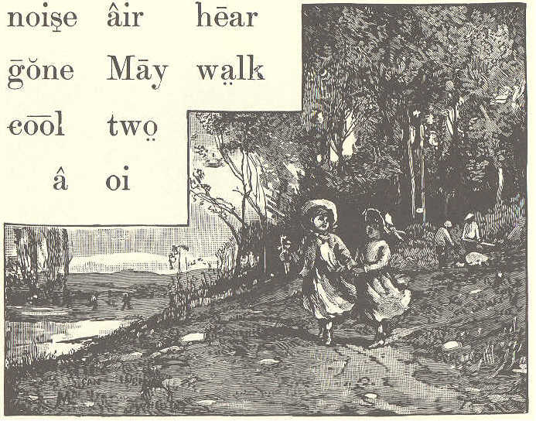
noise air hear
gone May walk
cool two
a oi

Two girls have gone out for a walk.
It is May, and the air is cool. They hear the birds sing in the trees, and they hear the noise of the frogs in the pond.
They see men at work and boys at play.
McGUFFEY'S PRIMER. 39

LESSON XXXIII.

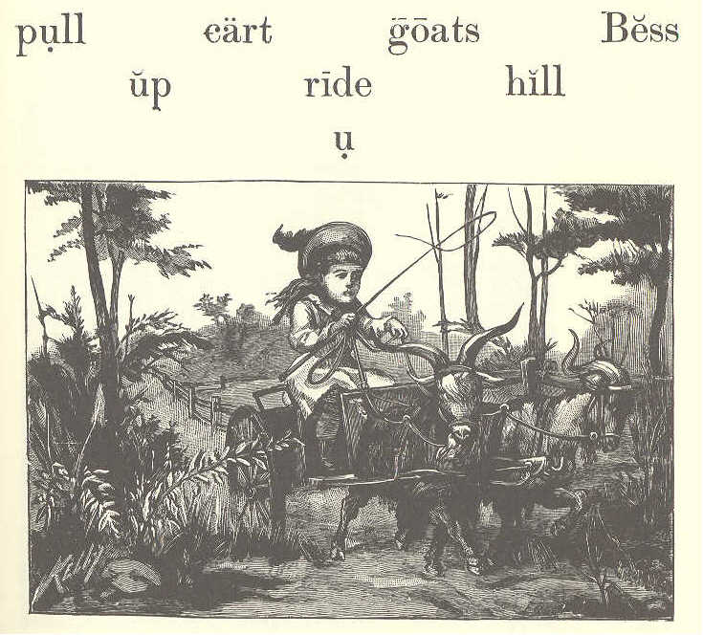
pull cart goats Bess
up ride hill
u

Bess has a cart and two goats.
She likes to ride in her cart.
See how the goats pull!
Bess is so big, I think she should walk up the hill.
The goats love Bess, for she feeds them, and is kind to them.
40 ECLECTIC SERIES.

LESSON XXXIV,

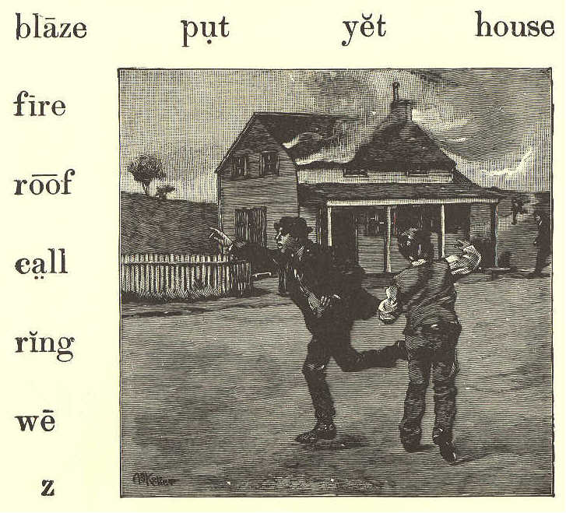
blaze put yet house
fire
roof
call
ring
we
z

This house is on fire.
Look! the roof is in a blaze.
Run, boys, and ring the bell. Call some men to put out the fire.
We may yet save the house, if we work hard.
McGUFFEY'S PRIMER. 41

LESSON XXXV.-REVIEW.

Bess, do you hear a noise?
Yes, Tom; what is it?
It is the mill by our house; logs are cut there.
How do they cut the logs, Tom,-with an ax?
Not with an ax, Bess; it is too hard work; they cut them with a saw.
May we not go and see the mill at work, Tom?
Yes, I think so. The air is cool, and we can walk in the shade. We should go soon, Bess, or the pile of wood will be gone.
Our two goats and the cart are here, Tom; we can ride to the mill. It is not up hill, and the goats can pull us fast.

42 ECLECTIC SERIES.

LESSON XXXVI.

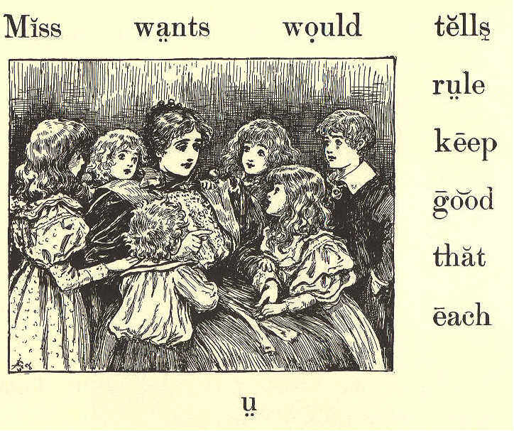
Miss wants would tells
rule
keep
good
that
each
u

The girls and boys all love Miss May; she is so kind to them.
Miss May tells them there is a rule that she wants them to keep. It is, "Do to each one as you would like each one to do to you."
McGUFFEY'S PRIMER. 43

This is a good rule, and all boys and girls should keep it.

LESSON XXXVII.

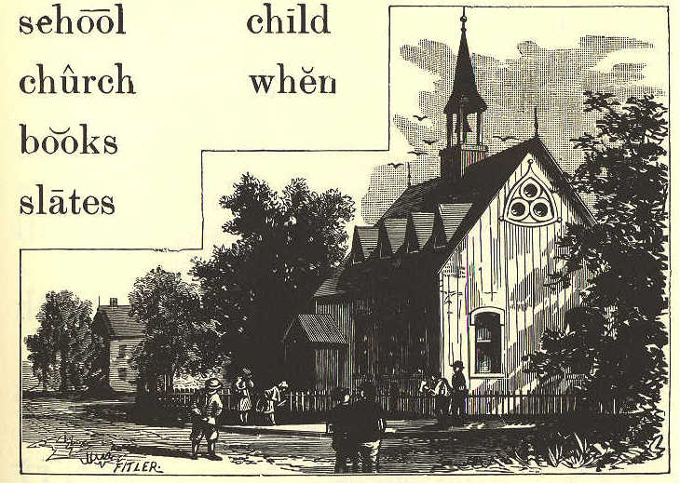
school child
church when
books
skates

What kind of house is this?
Do you think it is a schoolhouse, or a church?
It looks like a church, but I think it is a schoolhouse.
44 ECLECTIC SERIES.

I see the boys and girls with their books and slates.
When the bell rings, they will go in.
A good child likes to go to school.

LESSON XXXVIII.
quail quick
seen kill
me oh
eat first
know Henry
qu
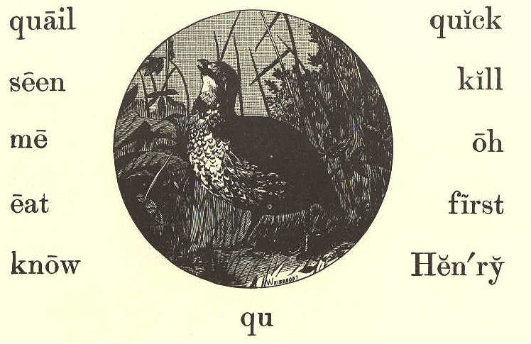

"John! come here. Be quick, and tell me what kind of bird this is."
"Do you not know, Henry?"
McGUFFEY'S PRIMER. 45

"Oh, no! what is it?" "It is a quail."
"It is the first quail I have seen. Is it good to eat?"
"Yes; but I should not like to kill it."

LESSON XXXIX.

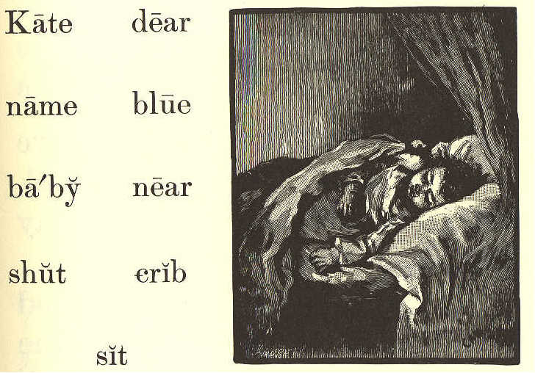
Kate dear
name blue
baby near
shut crib
sit

Is not this a dear baby in the crib?
46 ECLECTIC SERIES

Her name is Kate, and she has big, blue eyes. You can not see her eyes, for they are shut.
Kate is a good baby; but she will cry if she is hurt, or if she is not well.
Bess likes to sit near the baby, and to rock her in the crib.

LESSON XL.-REVIEW.

Henry Black and Ned Bell live near our house. They go to school, and I see them go by each day with their books and slates.
Miss May tells the girls and boys that they should be at the schoolhouse when the bell rings. So Henry walks fast, and is first at school. He is a good boy,
McGUFFEY'S PRIMER. 47

and wants to keep the rule of the school.
Ned is not a good boy. I do not think he likes to go to school or to church.
I saw him try to kill a quail with a stone. The quail is too quick a bird for that, and Ned did not hurt it; but I know that a good child would not try to kill a bird.

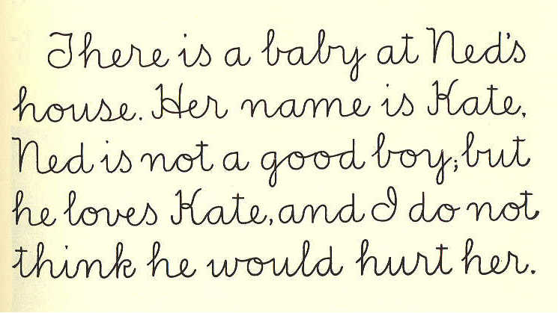
There is a baby at Ned's
house. Her name is Kate.
Ned is not a good boy, but
he loves Kate, and I do not
think he would hurt her.

48 ECLECTIC SERIES.

LESSON XLI.

light far its high
where sea tall were

The tall house which you see on that high rock is a lighthouse. At night its light is seen far out at sea, and the men on ships can tell where to go.
If it were not for this, they would run on the rocks.
How would you like to live in a lighthouse?

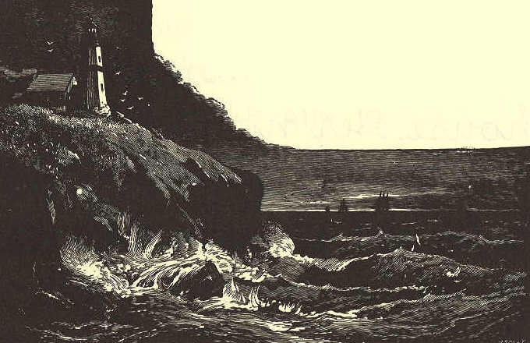
McGUFFEY'S PRIMER. 49

LESSON XLII.

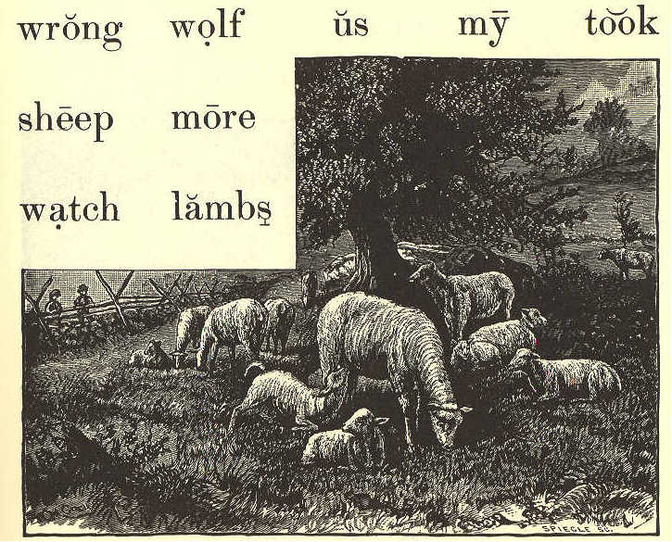
wrong wolf us my took
sheep more
watch lambs

Let us watch the sheep as they feed on the hills. They like to eat the new grass.
Do you see my two lambs? I had two more; but an old wolf took them one night.
I love my pet lambs. It would be wrong to hurt them.
50 ECLECTIC SERIES.

LESSON XLIII.

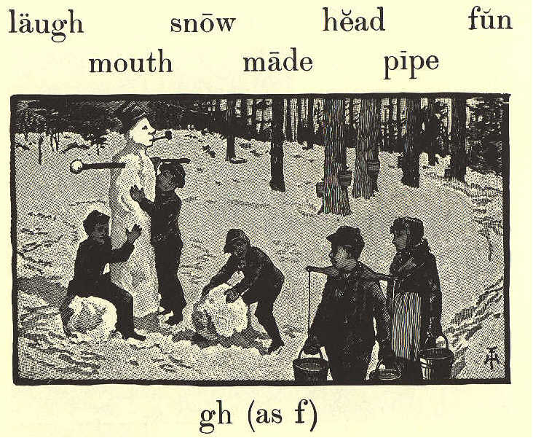
laugh snow head fun
mouth made pipe

gh (as f)

The boys have made a big snow man.
They have put a tall hat on his head, and an old pipe in his mouth.
Hear them laugh as they play!
It is good fun for the boys.
They would like to have it snow all day and all night.
McGUFFEY'S PRIMER. 51

LESSON XLIV,

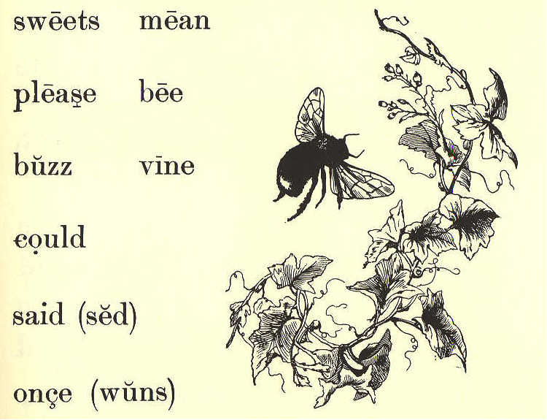
sweets mean
please bee
buzz vine
could
said (sed)
once (wuns)

"Buzz! buzz!" a bee said to Mary.
"What do you mean?" said Mary. "Please tell me once more."
"Buzz! buzz! buzz!" but Mary could not tell its wants.
I think it said, "Please let me get some sweets in this vine."
52 ECLECTIC SERIES.

LESSON XLV.-REVIEW.

One day Nat and I sat on the high hill by the sea, where the tall lighthouse stands. We could look far out, and could see the ships at sea.
As we sat there, we saw a man near by, with some sheep and lambs. The man had a pipe in his mouth. He sat with us, and let the sheep eat the grass.
What fun it is to see lambs play! It made us laugh to see them.
The man said that once, when the sheep and lambs were out in the snow, an old wolf took one of the lambs, and ran off with it.
I think that men should watch their sheep, so that a wolf can not catch them.
McGUFFEY'S PRIMER. 53

LESSON XLVI.

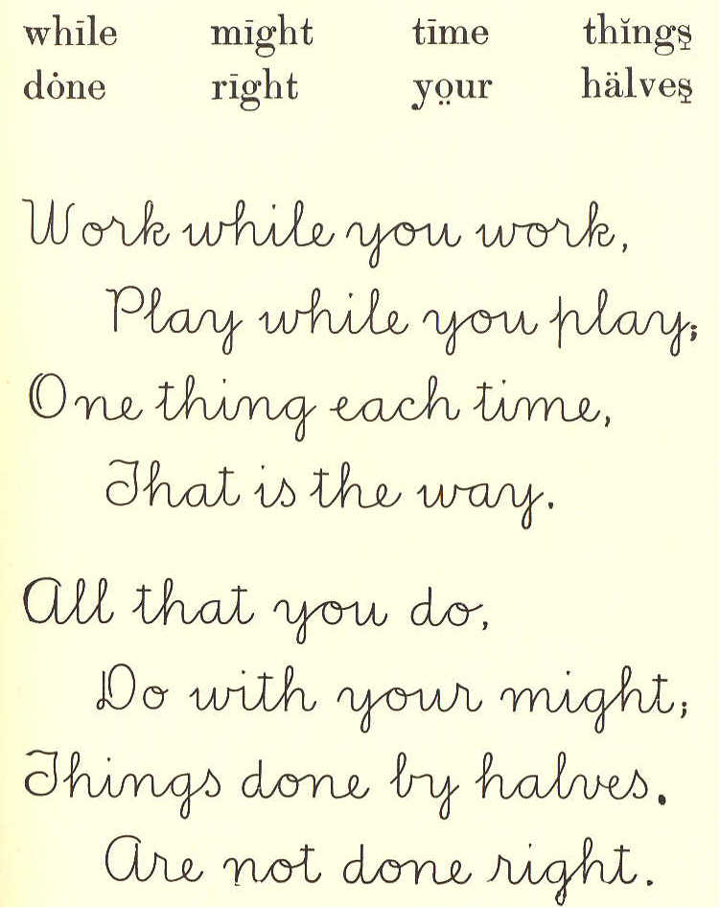
while might time things
done right your halves

Work while you work,
Play while you play,
One thing each time,
That is the way.

All that you do,
Do with your might,
Things done by halves,
Are not done right.
54 ECLECTIC SERIES.

LESSON XLVII.

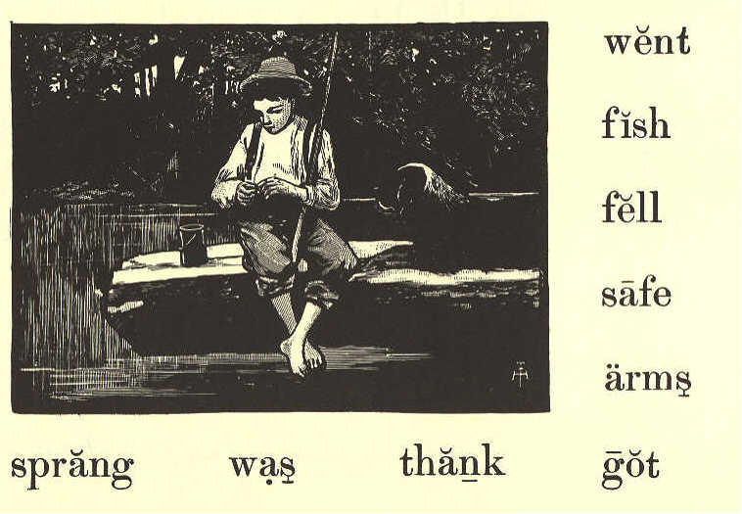
went
fish
fell
safe
arms
sprang was thank got

One day John went to the pond to fish. His dog, Watch, went with him.
John sat on a log for a time, but did not catch a fish.
As he got up to go, he fell off the log.
Watch sprang in to save him. John put his arms round the
McGUFFEY'S PRIMER. 55

dog's neck, and was soon safe on the log once more.
"Thank you, my brave old dog," said John to Watch.

LESSON XLVIII.

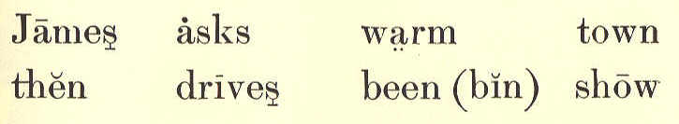
James asks warm town
then drives been(bin) show

James has been to the mill.
The day is warm, and he lets his horse stand
in the shade.

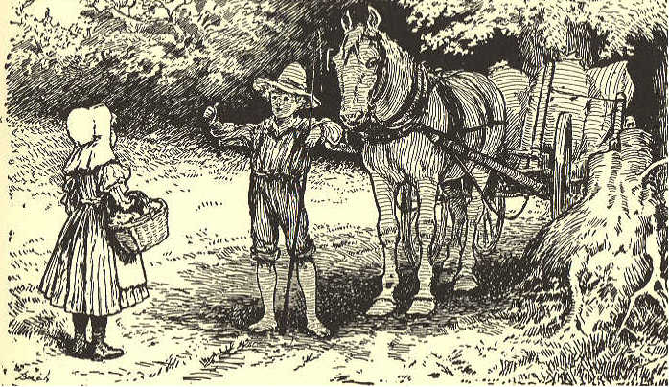
56 ECLECTIC SERIES.

A girl asks him to show her the way to the town. He tells her the way, and then drives on.

LESSON XLIX.

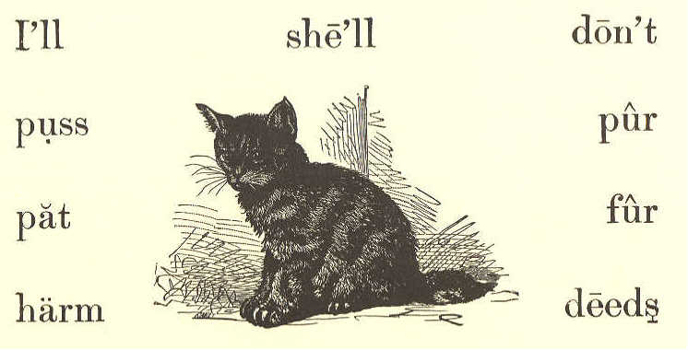
I'll she'll don't
puss pur
pat fur
harm deeds

I love my dear puss,
Her fur is so warm;
And, if I don't hurt her,
She'll do me no harm.

I'll pat my dear puss,
And then she will pur,
And show me her thanks
For my kind deeds to her.
McGUFFEY'S PRIMER. 57

LESSON L.

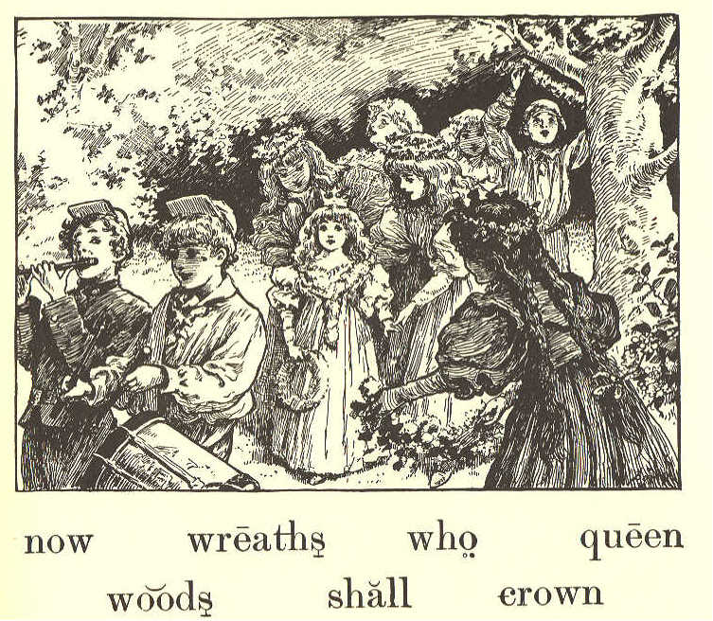
now wreaths who queen

woods shall crown

It is the first of May. The boys and girls have gone to the woods to have a good time. See them at their play.
The girls have wreaths in their hands.
Now they will crown some one
58 ECLECTIC SERIES.

Queen of the May. Who shall it be?
It should be the best girl, and that is Kate.

LESSON LI.
God small from
world moon
shine nut
long ago
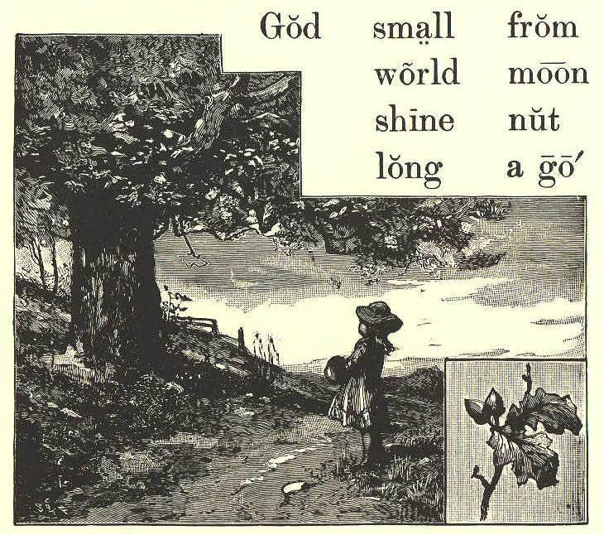

Do you see that tall tree?
Long ago it sprang up from a small nut.
McGUFFEY'S PRIMER. 59

Do you know who made it do so?
It was God, my child. God made the world and all things in it. He made the sun to light the day, and the moon to shine at night.
God shows that he loves us by all that he has done for us. Should we not then love him?

LESSON LII.

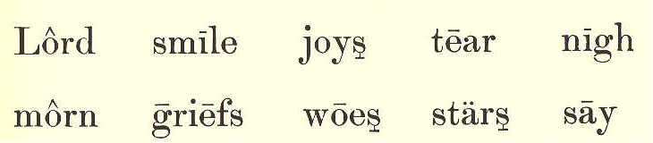
Lord smile joys tears nigh
morn griefs woes stars say

When the stars, at set of sun,
Watch you from on high;
When the light of morn has come,
Think the Lord is nigh.
60 ECLECTIC SERIES.

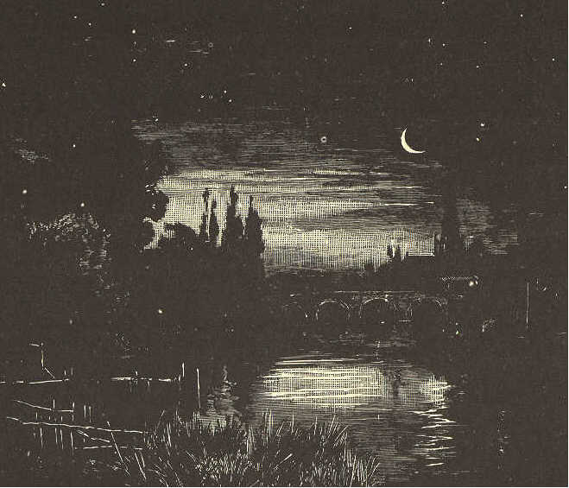

All you do, and all you say,
He can see and hear;
When you work and when you play,
Think the Lord is near.

All your joys and griefs he knows,
Sees each smile and tear;
When to him you tell your woes,
Know the Lord will hear.
McGUFFEY'S PRIMER. 61

SLATE EXERCISES

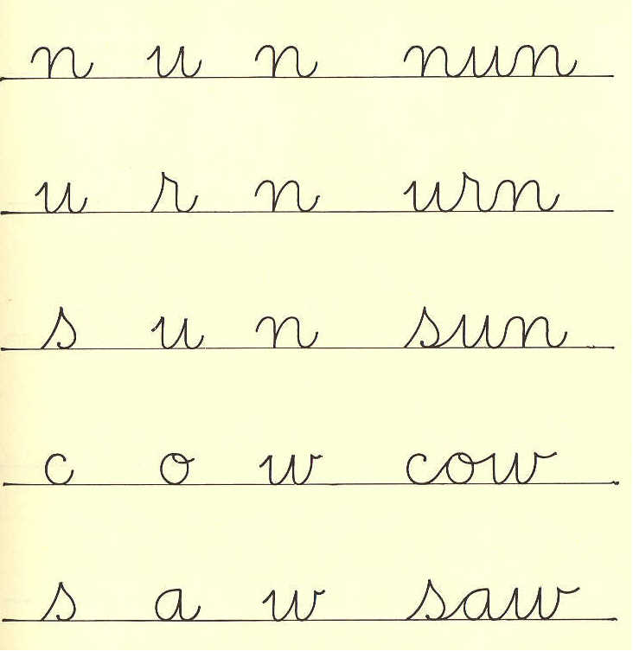
n u n nun
u r n urn
s u n sun
c o w cow
s a w saw
62 ECLECTIC SERIES.

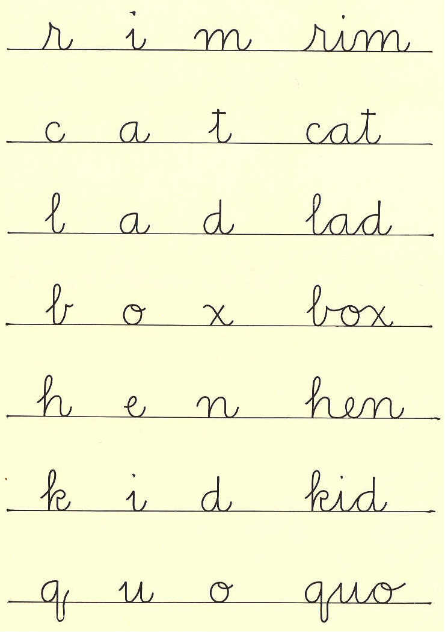
r i m rim
c a t cat
l a d lad
b o x box
h e n hen
k i d kid
q u o quo
McGUFFEY'S PRIMER. 63

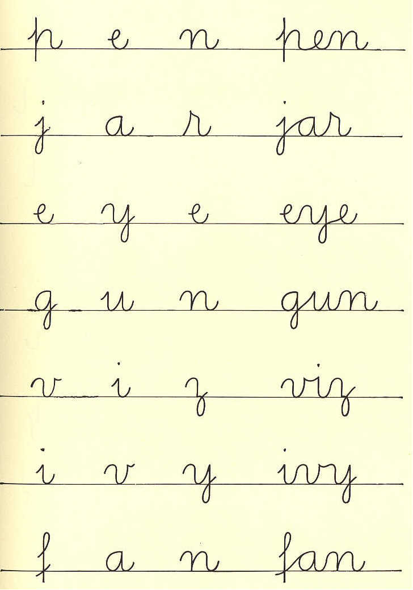
p e n pen
j a r jar
e y e eye
g u n gun
v i z viz
i v y ivy
f a n fan
64 ECLECTIC SERIES.

SCRIPT ALPHABET

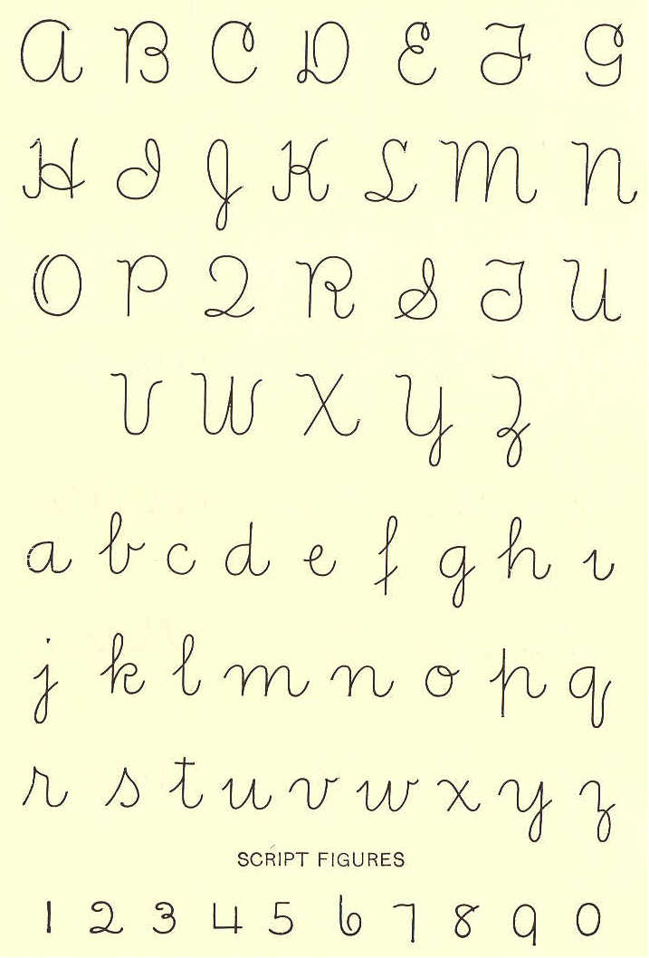
A B C D E F G
H I J K L M N
O P Q R S Y U
V W X Y Z
a b c d e f g h
i j k l m n o p q
r s t u v w x y z
SCRIPT FIGURES
1 2 3 4 5 6 7 8 9 0

