A Visit From Saint Nicholas
By Clement Clarke Moore

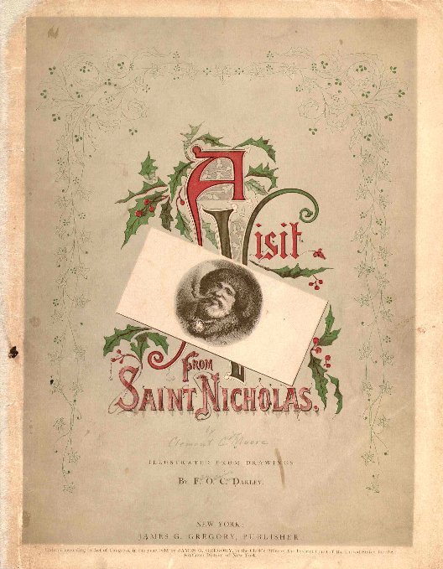
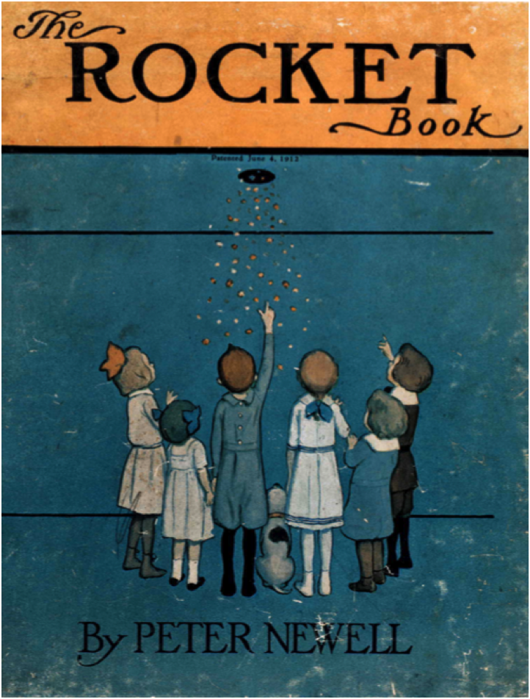
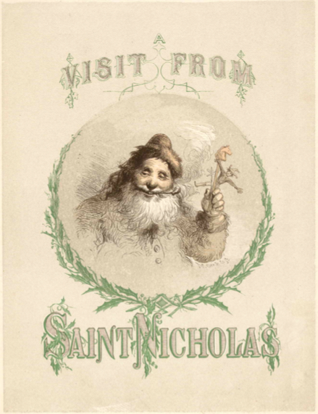
Account of a Visit from St. Nicholas

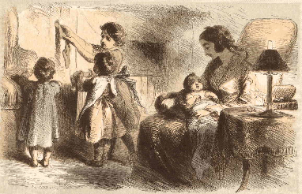

'Twas the night before Christmas, when all thro' the house
Not a creature was stirring, not even a mouse;
The stockings were hung by the chimney with care,
In hopes that St. Nicholas soon would be there;
The children were nestled all snug in their beds,
While visions of sugar plums danc'd in their heads,
And Mama in her 'kerchief, and I in my cap,
Had just settled our brains for a long winter's nap
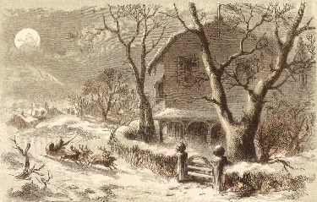
When out on the lawn there arose such a clatter,
I sprang from the bed to see what was the matter.
Away to the window I flew like a flash,
Tore open the shutters, and threw up the sash.
The moon on the breast of the new fallen snow,
Gave the lustre of mid-day to objects below;
When, what to my wondering eyes should appear,
But a minature sleigh, and eight tiny rein-deer,
With a little old driver, so lively and quick,
I knew in a moment it must be St. Nick.
More rapid than eagles his coursers they came,
And he whistled, and shouted, and call'd them by name:

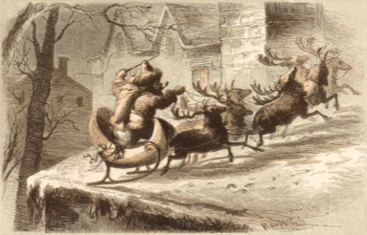

"Now! Dasher, now! Dancer, now! Prancer and Vixen, "
On! Comet, on! Cupid, on! Dunder and Blixem; "
To the top of the porch! To the top of the wall! "
Now dash away! Dash away! Dash away all!"
As dry leaves before the wild hurricane fly,
When they meet with an obstacle, mount to the sky;
So up to the house-top the coursers they flew,
With the sleigh full of toys — and St. Nicholas too:
And then in a twinkling, I heard on the roof
The prancing and pawing of each little hoof.
s I drew in my head, and was turning around,
Down the chimney St. Nicholas came with a bound:

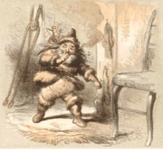

He was dress'd all in fur, from his head to his foot,
And his clothes were all tarnish'd with ashes and soot;
A bundle of toys was flung on his back,
And he look'd like a peddler just opening his pack:
His eyes — how they twinkled! His dimples: how merry,
His cheeks were like roses, his nose like a cherry;
His droll little mouth was drawn up like a bow,
And the beard of his chin was as white as the snow;
The stump of a pipe he held tight in his teeth,
And the smoke it encircled his head like a wreath.
He had a broad face, and a little round belly
That shook when he laugh'd, like a bowl full of jelly:
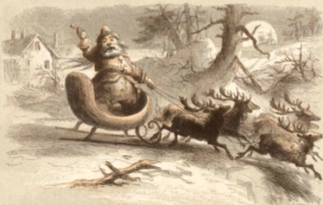

He was chubby and plump, a right jolly old elf,
And I laugh'd when I saw him in spite of myself;
A wink of his eye and a twist of his head
Soon gave me to know I had nothing to dread.
He spoke not a word, but went straight to his work,
And fill'd all the stockings; then turn'd with a jerk,
And laying his finger aside of his nose
nd giving a nod, up the chimney he rose.
He sprung to his sleigh, to his team gave a whistle,
And away they all flew, like the down of a thistle:
But I heard him exclaim, ere he drove out of sight
— Merry Christmas to all, and to all a good night.

